How does political finance regulation influence control of corruption?

Improving good governance in Latin America

Alvaro López, Mario Rodríguez and Mariano Valentini

1. Introduction 4

2. Literature Review 5

From Corruption to Control of Corruption 5

Definition of Political Finance 8

The Link between Political Finance and Corruption 9

Political Finance and Corruption in Latin America 16

Public Expenditure and its Relation with Corruption 18

Judicial Independence: A Precondition for Control of Corruption? 19

3. Methodology 20

4. Results 23

Descriptive statistics of the world PFR dataset 23

Political Finance Regulation and Control of Corruption in LA 27

Panel regression model of Latin America 32

Variable description 33

Simple regression model 33

Multivariate regression model 34

How to improve control of corruption in Latin America? 37

5. Studies of Argentina, Chile and Mexico 38

Argentina 38

Corruption Context 38

Argentina´s performance within Latin America 39

The strategy to improve control of corruption in Argentina 42

Judicial Independence 43

Public Investment Control 46

Political Finance Regulation 47

Specific measures to improve control of corruption in Argentina 49

Chile 50

Mexico 50

Control of Corruption in Mexico 50

Political Finance 53

Judicial Independence 54

Public Investment 55

Improving the control of corruption in Mexico 56

References 60

Figure I. Worldwide levels of PFR 2015 (source: own calculations) 24

Figure II. PFR Index times series by regions, 1996-2015: America, Europa, Africa, Oceania, and Asia 25

Figure III. PFR and WB Control of Corruption Index time series, 1996-2015 (Source: own calculations) 26

Figure IV. PFR Sub-Index level in 1996 and 2015 by region. BLPI: Bans and limits on private income, PF: Public funding, RS: Regulation on spending, OS: Oversight and sanctions (source: own calculations) 27

Figure V. PFR Index in LA 2015 (Source: own calculations) 28

Figure VI. PFR Sub-index time series in 1996 and 2015 for Latin America. BLPI: Bans and limits on private income, PF: Public funding, RS: Regulation on spending, OS: Oversight and sanctions (Source: own calculations) 29

Figure VII. PFR Index level in 2006 and 2015, Latin America (Source: own calculations) 29

Figure VIII. Mean PFR Index and World Bank Control of Corruption time series in 2006-2015, Latin America (Source: own calculations) 30

Figure IX. PFR Index and World Bank Control of Corruption change in 2006-2015, Latin America (Source: own calculations) 31

Figure 10. CoC and PFR Scatterplot 2006 and 2015 (Source: own calculations) 32

Figure XI. Marginal Effects of PFR on CoC for different levels of JI (Source: own calculations) 35

Figure XII. Marginal Effects of PI on CoC for different levels of JI (Source: own calculations) 36

Figure XIII. Predicted vs. Actual CoC. Equilibrium Models 2014 & 2006-2014. (Source: own calculations) 36

# 1. Introduction

The corruption of political parties is one of the most critical issues for democracies, especially for young ones. On one hand, corrupt parties can seriously damage democracy by undermining public trust, increasing voters’ disillusionment and even leading to authoritarian regimes. On the other hand, honest parties play a vital role within democracies, since they are the bridge between people and their governments. (Blechinger 2002, p. 4)

Today, a relative majority of countries are organized around regular elections and people are involved in public affairs more than ever. Yet, corruption is expanding among new democracies and not decreasing, contrary to common sense. (Mungiu-Pippidi 2015, p. 2)

Latin America is the perfect example of this situation. Even though democracies in the region experienced an important consolidation in the last decades, corruption scandals related to the influence of money in politics did not stop. Actually, issues like the illicit funding of candidates and parties by criminal organizations, as well as the misuse of public resources by parties in government, have gained weight in the public agenda.

Therefore, how to control corruption within the realm of political finance in Latin America is the central question we will seek to answer through this thesis. We will focus our efforts in developing an index of *political finance regulation,* with the biggest database about this topic in the world. Our main goal is to identify how different levels and types of party finance regulation interact with control of corruption in the world, while taking a special focus in Latin America.

Furthermore, the literature states that political corruption is a multidimensional problem, so control of corruption is presented as an equilibrium model. In addition to party finance regulation, we will also focus on a variable that can be used to measure opportunities for corruption: *public spending*. Using data from capital expenditures from Latin American countries, we will analyse how control of corruption in Latin America interacts with both political finance regulation and discretionary public spending. Public spending and political finance regulation will be analysed in conjunction with other variable said to be vital in control of corruption, judicial independence.

Finally, we will analyse changes in control of corruption, political finance regulation, judicial independence and public investment in three countries: Argentina, Chile and México, as well as the exploration of recommendations to improve control of corruption in the three countries.

# 2. Literature Review

## From Corruption to Control of Corruption

Corruption is not harmless and has indisputable negative consequences for societies. It leads to massive brain drain and produces disincentives for hard working and integrity. It also affects fair competition and gender equality, in addition to distorting public spending and equal access to public jobs. (Mungiu-Pippidi 2015, p. 2)

Notwithstanding the importance of the concept, the definition of corruption represents a challenge. According to Mungiu-Pippidi (2015, p. 3), there seems to be an agreement around the idea that “corruption involves some undue private profit (for someone) due to the abuse of an entrusted public authority”.

Indeed, since 2005, the United Nations Convention Against Corruption (UNCAC) provided a frame for the idea of corruption. Despite the fact that this international instrument does not offer a clear definition of corruption, the Convention states in its first article that one of its purposes is “[t]o promote integrity, accountability and proper management of public affairs and public property.” (UNCAC, Art. 1.c) Moreover, the first preventive measure of the Convention states that: “Each State Party shall, in accordance with the fundamental principles of its legal system, develop and implement or maintain effective, coordinated anti-corruption policies that promote the participation of society and reflect the principles of the rule of law, proper management of public affairs and public property, integrity, transparency and accountability.” (UNCAC, Art. 5.1)

According to Mungiu-Pippidi (2015, p. 11), the classic definition of corruption made by Nye in 1967, as a “behaviour which deviates from the formal duties of a public role because of private-regarding (personal, close family, private clique) pecuniary or status gains; or violates rules against the exercise of certain types of private-regarding influence)” highlights the connection between the public and the private spheres. However, this definition does not consider situations where “laws and policies themselves are corrupt and seek to create legal privileges for those connected with the source of authority granting the privilege”.

Furthermore, there are three main characteristics of the idea of corruption. First, fraudulent behaviours between private actors are normally defined as “fraud”, staying out the realm of corruption. Second, the notion of “abuse of public authority” instead of “public interest” or “public trust”, is assumed to avoid cases where public interests or trust can be damaged by private parties. Third, corruption exceeds the notion of “deviation from the norm”, since the idea of “public interest” of this definition implies a high level of relativism and has mutated over the years and cultures. (Mungiu-Pippidi 2015, p. 12)

Based on these characteristics, Mungiu-Pippidi (2015, p. 15) notes that agreeing on a unique and universal definition of corruption is complicated, since it is a phenomenon affected by many disciplines. She highlights that in societies without ethical universalism, the equal treatment of all the members of a society by the government when implementing laws and policies, the different kinds of corruption can be immeasurable, due to the perpetuation of groups taking advantage of public resources. (Mungiu-Pippidi 2015, p. 17)

In a theoretical-practical approach, the author turns the focus from idea of “corruption” to “control of corruption”, defined as “a given society´s capacity to constrain the use of public authority to generate private rents detrimental to overall social welfare”. (Mungiu Pippidi 2015, p. 18)

Then, the key question is how a certain society can constrain the missuses of public resources by an individual or a group in their own and private benefit, and guarantee that the state serves to the social wellbeing. Thus, Mungiu-Pippidi (2015, p. 19) addresses the issue of “corruption”, not from an individual perspective, but from a societal one. The difference is that while the former would be aimed at the undue profits made by individuals due to the abuse of public authority, the latter sees corruption “as an intrinsic part of certain governance context, a social allocation mode”.

This approach exceeds the notion of corruption as a simple aggregation of individual corrupt acts. Conversely, it is focused on how the work of institutions and the rules of game determine the allocation of public resources. Mungiu-Pippidi (2015, p. 23) highlights those countries with the highest levels of control of corruption that managed to institutionalize open and non-discriminative access to their institutions.

Indeed, “human agency” is indispensable to make progress in governance. It means to move from “particularistic” societies where states and their institutions are used as instruments for particular private profits, to more “ethical universalistic” societies where institutions seek out the general welfare. (Mungiu-Pippidi 2015, p. 82)

However, when it comes to the question about the right kind of human agency, the answer tends to be contested. Implementing anticorruption laws, liberalizing trade, increasing accountability, are just some of the options normally analysed.

Actually, the answer will depend on the type of “control of corruption model” we choose. Mungiu-Pippidi differentiates between three main models of control of corruption. The first one is based on structural factors. Traditional factors, like trust, natural resources, and/or geographical and living conditions, as well as modernization conditions like literacy rates, urbanization and life expectancy. The second model, aimed at the promotion of anti-corruption legislation and the adoption of anticorruption tools for domestic implementation such as civil service merit-based recruitment, administrative reforms and independent control agencies, which can include freedom of information legislation, anticorruption agencies and ombudspersons. Finally, a third model of control of corruption is identified: the equilibrium model. Based on the understanding of corruption as equilibrium between costs and benefits pioneered by Klitgaard (1988) and Huther and Shah (2000), Mungiu-Pippidi (2015, p. 116) states that “the ideal model to explain control of corruption should be an equilibrium model without a principal-agent perspective”, in order to overcome those situations where principals are the ones to be enforced.

The equilibrium model understands control of corruption as the balance between opportunities or resources to corrupt and deterrents or constraints imposed by society as a whole. Indeed, this approach is aimed at the collective capacity to enforce good governance, which means the capacity of a society to reduce particularistic situations and increase ethical universalism among their institutions. (Mungiu-Pippidi 2015, p. 116)

Then, the equilibrium model formula of control of corruption developed by Mungiu-Pippidi (2015, p. 117) is:

“*Control of corruption= Constraints (Legal + Normative) – Opportunities (Power Discretion + Material Resources)”*.

Based on this model, we will seek to address a central issue of particularistic societies and corruption. When ethical universalism is not the norm, private entities usually make “favours” to political parties and/or political candidates in order to be reciprocated once that party/person is in charge of public resources. (Mungiu-Pippidi 2015, p. 16)

Scholars have analysed a significant dimension of control of corruption related to this problem: *political finance regulation*. However, it seems that there is not an agreement on the advantages of this approach when it comes to decrease corruption. While some specialists and international organisations encourage states to adopt a broader regulatory framework, some research argues that those regulations are limited, since they cannot prevent the influence of money.

The discussion regarding political finance regulation can be tackled from different theoretical angles and regional perspectives. In this study, we will focus our efforts to understand how political finance regulations have influenced control of corruption, specifically in Latin America. In other words, we will seek to identify if political finance regulation has been an effective constraint to particularism in Latin America.

## Definition of Political Finance

To define other of the main concepts of this thesis, we will follow the guidelines provided by the International Institute for Democracy and Electoral Assistance (IDEA), which developed the most complete database about political finance regulation in the world. Even though political finance usually refers to money flowing in the political process, we will focus on issues “most closely related to the process of electoral democracy”, sticking to the definition of political finance as “the (legal and illegal) financing of ongoing political party activities and electoral campaigns (in particular, campaigns by candidates and political parties, but also by third parties).” (International IDEA 2014, p. 2)

Internal political parties’ behaviour, availability of state resources and private founders´ activities, are some of the elements that comprise the realm of political finance. Regulation of at least some of these matters has been adopted by most states in the last decades. Political finance regulation, then, looks to prevent the missuses of money in politics, as well as to provide the necessary framework to enforce some mandates and sanction those who violates them. (International IDEA 2014, p. 2)

Indeed, political finance regulation is seen as a key variable of more transparent and legitimate democracies. The need to regulate money in politics is usually considered as an indispensable step to diminish the influence of big donors over candidates and parties. The Global Commission on Elections, Democracy and Security, for instance, stated that "the failure to regulate political finance threatens to hollow out democracy and rob it of its unique strengths". (Kofi A. Annan 2014, p. IV International IDEA Report)

The lack of political finance regulation has been identified as an opportunity for organized crime to influence politics and as a cause of negative economic development. Former UN Secretary General Kofi Annan called for a better control of political finance, meaning that governments should regulate donations and expenditures effectively, increase transparency of donations, require disclosure of financial sources, adopt sanctions for non-compliance and legislate over effective monitoring and enforcement mechanisms. (Kofi A. Annan 2014, p. IV International IDEA Report)

However, there seems to be a general agreement on the conviction that more regulation does not necessarily mean more transparency or a better balance of power between those with money and citizens in general. Indeed, IDEA concludes that in some situations, depending on the social-political context and/or the aims of the regulation, a high level of regulation may be not desirable. (IDEA 2014, p. 4) All in all, this shows an open discussion about the capacity of political finance regulation to influence control of corruption within states.

## The Link between Political Finance and Corruption

The scholar debate about political finance can be traced back decades. The issue was discussed in the 1940s, when specialists could not reach an agreement on how to address limitations to contributions and expenditures of candidates and parties over electoral campaigns in the US. (Overacker 1941)

To tackle the problem of the "power of the purse" for the presidential campaign in 1940, the US Congress decided to increase party finance regulations. There were already some limitations to the amount of contributions and total expenditures of candidates and parties since 1911. Nevertheless, through the "Hatch Act II", Congress also limited the amount of money that an individual could contribute to a national committee and the level of expenditures permitted to these agencies. (Overacker 1941)

The results of the new legal framework were poor. Its subjects adopted deliberated strategies to circumvent the goal of the law without violating its letter; both major US parties decentralized the collection and distribution of funds. Indeed, Overacker concluded that the endeavour to regulate camping funds was "ambiguous, unworkable, and conducive to unhealthy political practices". Based on the evidence, Overacker disputed the advice from other specialists who were in favour of more party finance regulation. Conversely, she supported the idea of increasing the publicity of party funding instead of passing new legal prohibitions. (Overacker 1941)

At the beginning of the 1960s, in a publication that was said to be "the starting point of the new subject [party finance]" (Blondel 1970), Heidenheimer went a step further in comparing political finance processes. After recognizing that a high quality comparative study on the topic would require greater amounts of data and more unified concepts, he looked to develop a comparative evaluation of data and information. At that time, Heidenheimer observed two polar models in terms of party finance processes. The first built around mass parties and based on membership fees. The second concerning cadre party, who’s financing relied upon the "whim of a few hidden large-scale contributors and ´interests´". (Heidenheimer 1963)

He stated that in the 1960s most Western parties were turning into mass parties and had started to diversify their sources of financial support, affecting financing patterns. Indeed, throughout his work, Heidenheimer compared party finance processes to identify the existence of a historical evolution. He touched upon the issue of regulation within this realm, but only accessorily. He observed that only a small amount of countries tried to prohibit corporate political donations like the US. Indeed, Heidenheimer concluded that there were tax laws on different countries that had considerable influence on the matter. However, he admitted that the application of regulations deserved much more detailed studies on a comparative level. (Heidenheimer 1963)

Over the 1960s some scholars observed a growing tendency among Western countries regarding party finance. They saw that in a number of countries, political parties were abandoning their traditional sources of income from the 19th and 20th centuries and changed towards a public subsidized system. (Blondel 1970, preface) Concerned about this phenomenon, they analysed the importance and effectiveness of political finance over electoral results, mainly focusing on the relationship between economic and political powers. Consequently, they went into the realm of party finance regulation. (Heidenheimer 1970)

Taking into account Max Weber´s assertion about how party finance defines the way in which influence spreads over the political system, Heidenheimer studied the different practices and experiences related to the rising spending and controlling of political funds. The scholar studied different regulations related to campaign expenditures, like spending limits and expenditures reporting requirements. (Heidenheimer 1970)

Moreover, he underlined the political discussion about Parties Law in Germany, specifically, the critique of the proposal of prohibiting corporate donations to parties and candidates on the basis of the American experience, which proved such these rules could be easily circumvented. Nevertheless, Heidenheimer observed a high correlation between the enforcement level of expenditures disclosure and the degree of public access to that information. (Heidenheimer 1970)

In the 21th century, still interested in the structure of modern mass parties, Heidenheimer turned his focus over to the relationship between party finance and political corruption. He argues that despite the creation of the Party Finance and Political Corruption of the International Political Science Association on the 1960s, for many decades there was a lack of studies that analyse “linkages between party finance processes and explicitly recognized patterns of political corruption”. The main reason is the difference in prevailing national ideas of political corruption. (Heidenheimer 2007, p. 764)

After linking a party and campaign expenditure index from the early 1960s and Transparency International’s (TI) Corruption Perception Index from 1995 to 1997, Heidenheimer found a pretty consistent relationship between both rankings. His study covered nine different countries and, taking into account the 30 years gap between both indexes, he concluded that higher campaign expenditure increased corruption. (Heidenheimer 2007, p. 772)

According to Mauro, government regulations are a key element for corruption. Based on economic research, he states that corruption takes place where rents exist, and since public regulations usually provide discretion to public officials, government restrictions tend to result in rent-seeking behaviour, like in the case of import quotas. (Mauro 1998)

He mentions different situations where government restrictions generate excessive profits increasing corruption likability. Examples are trade constraints, favourite industrial policies, price controls, multiple exchange rate policies, foreign exchange allocation schemes and provision of credit under governmental control. Also, he underlines rent-seeking contexts in the absence of governmental intervention, like the case of natural resources, which generate extraordinary profits, and therefore, increase the incentives to bribe those who allocate extraction rights. (Mauro 1998)

Despite the depth of his analysis, Mauro does not mention party finance regulation as a cause of corruption. The fact that this kind of rules seek to restrict politicians instead of empower them may be a central difference with regulations that enable rent-seeking scenarios. Party finance regulation is not mentioned as a tool to fight corruption, at least, in a direct way. Among the different options analysed by the author to reduce corruption, the need of transparency is recurrent; budget transparency, as well as, government expenditures transparency are hopeful alternatives. (Mauro 1998) So, depending on how we define party finance regulation, as a rent-seeking generator or a transparency tool, our object of study can be considered as a corruption opportunity or constraint.

According to Wilcox, there seems to be a general agreement around the positive effects of disclosure within the campaign finance system in the US. Indeed, the obligation that candidates, political parties and interest groups reveal their funding sources and how they expend money tends to be accepted as a way to reduce corruption. (Wilcox 2001, p.2)

Disclosure regulation has its advantages and disadvantages. Among the first group, the improvement of corruption control and civic accountability stand out. Inversely, overexposure of private donors, small parties’ under-funding and rent seeking are mentioned as possible costs. (Wilcox 2001, p. 38)

After studying the US experience, Wilcox concludes that a good disclosure system would need to define "campaign activity" broadly in order to avoid circumventions of the rules. It also has to provide the policymaking authority with the ability to adapt to different practices. However, it is important to balance the costs and benefits of the disclosure system, considering the social and political context. (Wilcox 2001, p. 38)

Based on different study cases, Blechinger underlines the importance of party finance regulation, mainly aimed at campaign finance, as well as intra- and external party anti-corruption laws. Nevertheless, to be effective it needs to be part of a broader strategy that includes party competition, more transparency, the monitoring of free media, an active civil society and up-to-date citizenry. (Blechinger 2002, p. 2)

On the subject of parties, Hopkin (2004) argues that following the decline in party membership, partially caused by scandals that feed the perception of politicians as corrupt, there has been changes in patterns of party finance, specifically a shift from the ‘mass party’ model of funding towards ‘elite party’ and ‘cartel party’ models. In this sense, party finance is a collective action problem in which rational self-interested group members will free ride and refuse to contribute to the party. He further identifies four ‘post-mass party’ financial strategies: the clientelistic mass party, the externally financed elite party, the self-financed elite party and the cartel party. He concludes that the mass party model remains closest to the ‘democratic’ ideal, while the state financed model is a pragmatic response to the decline in party membership.

The level of regulation of the political process may also depend on the democratic context. After analysing party laws of 39 countries, Karvonen (2007) ascertains that party laws regulate political parties differently depending on the democratic status of its countries. In non-democratic states, the establishment tends to use these laws to restrict the freedom of their opponents, while in new democratic states the law counteracts lingering anti-democratic tendencies. Finally, in stable democracies, the law is seen as a prerequisite for regulation of subsidies and political finance. Furthermore, these laws tend to cement the existing party structures. (Karvonen 2007)

According to Scarrow (2004), political finance is one of the most problematic regulatory areas of democracies, because it is connected to the aim of guaranteeing a certain minimum level of political equality in a context where wealth is unequally distributed. After analysing party finance reforms in Germany and England, Scarrow notes that scandals had weak consequences in regulatory results, unless one party advances the cause. Also, that when parties endorse reform, it does not mean that they will adopt it. Conversely, the deepest effects in party finance reforms were reached thanks to the intervention of non-party regulatory bodies, such as independent commissions appointed by the government, as well as courts of justice, among others. Even in cases of parties willing to compete over party regulation issues, the adoption of self-denying rules may be more successful if there are external forces suggesting and/or imposing reforms. (Scarrow 2004, p. 669)

Based on evidence from 20 years, Scarrow affirms that campaign spending matters. Even in scenarios ruled by party loyalty and spending centralized in national parties, individual candidates’ spending can improve electoral chances. Moreover, the spending by challengers tends to be more effective than officeholder’s spending. Therefore, attempts to limit the impact of money over politics through regulations can work as a protection to the ruler party or candidate and as a limitation to the challengers. (Scarrow 2007,p. 201)

Rules aimed at increasing transparency of the relation between donors and recipients, like an increase of disclosure or specific prohibitions to donations; tend to have a dual effect. They decrease people´s distrust on candidates and parties, since they appear less responsive to donors’ preferences, but can have the counter-effect of scandalizing former accepted behaviours. (Scarrow 2007)

According to research from the US, introducing public funding does not guarantee more citizens´ trust in their parties. However, Scarrow (2007) notes a lack of investigations on the issue. He concludes that the comparative studies which address the assumption that politicians in need of funding may pay disproportionate attention to their funders´ will are unlikely to provide a universal solution to the problem.

Pierre et al. (2000) study the consequences of the introduction of public funding to party dynamics. They take the arguments in favour and against the introduction of subsidies to political parties and examine if they are supported by empirical data. On the side of advocacy for state subsidies, they identify the need to maintain parties for their importance to a democratic government, the fact that they can serve as a platform for citizens’ political participation and the rising costs of running a party in a modern democracy. The arguments for removing them are the supposed co-optation of the state by the parties, that they petrify the party system by not allowing entrance to new parties and because they eliminate parties’ interest in sustaining or increasing their membership.

The study finds that petrification of the party system has not taken place in systems with extensive support for parties and that the decline in membership of parties could not be attributable to the introduction of subsidies. Furthermore, it confirms that subsidies don’t have a significant impact on the structure of the party system and that they might provide funds to develop the creation of new parties. (Pierre et al. 2000)

For Pinto-Duschinsky (2002, p.78) state funding has not cured the problem of corrupt political funding because “some of the most serious scandals have occurred in countries with generous public subsidies”. He states that the failure might be related with the fact that heads of government have a secret slush to use as they see fit, legislatures have similar funds for development projects in their constituencies, public officials are required to donate part of their salaries to parties and the use of state resources for electioneering functions could be used as an indirect public subsidy. In the same sense, he argues that these laws are not respected because of lack of enforcement. He states that political finance rules are ignored due to the lack of political will and because they apply to a limited range of political payments. Related to this, he underscores the dangers of assuming that the problems of political financing are amenable to legislative remedies, stressing the need for a focus on enforcement. (Pinto-Duschinsky 2002)

On the same note, van Biezen and Kopecky (2007) propose an analytical framework that distinguishes between three different dimensions of the party–state linkage: the dependence of parties on the state, the management of parties by the state and the control of the state by parties. They argue that despite regional variations, the widespread availability of public subsidies demonstrates that subventions have become a pervasive phenomenon in contemporary democracies and that the regulation of party activity indicates that parties are more extensively managed by the state. Also, they determine that there is a pervasiveness of party rent seeking, which suggest that parties are in some degree in control of the state and state resources. (Van Biezen and Kopecky 2007)

Van Biezen (2004) notes that the concern of the impact of money in political finance has acquired an increasing importance due to perceptions of dishonesty of party leaders. The author explores the variation in existing regulatory frameworks and provides a typology of financing regimes, which focuses on the control and transparency of income and expenditures, as well as the availability of direct and indirect public funding. The study uses the Political Finance Database of IDEA to examine structural and institutional explanations for patterns of party regulation. The research found no explanatory significance of the pervasiveness of corruption, the level of economic development or the maturity of the democracy. (Van Biezen 2004)

Using the World Bank’s index of corruption, Van Biezen (2004) found no clear relationship between the existence of disclosure rules, the availability of public funding and the level of corruption. Furthermore, the study concluded that countries with higher levels of corruption may be more likely to establish legal norms to control political donations and expenditures, but are not necessarily more inclined to introduce transparency legislation or to concede a greater role to state funding. Contradicting similar research, it suggests that political finance regulations might not be a product of an increase in political scandals.

Casal Bértoa et al. (2012) analysed if public funding and political finance regulations are related to the perception of party corruption. Like most of the scholars who tackle this topic, the authors note a lack of research concerning the influence of political finance regulation on corruption.

Using a dataset developed at Leiden University, with information of political finance aspects in Europe and Latin America, these scholars employ a quantitative approach to verify the assumption that political finance regulation has a positive effect on party corruption trough a comparison of 28 European and 9 Latin American countries. Based on their data, the scholars conclude that more political finance regulation does not mean a lower perception of party corruption. (Casal Bértoa et al. 2014) The scholars note that political finance regulation does not help to drop the levels of perceived corruption among political parties. Actually, neither restrictive legal frameworks where the state is the main financial contributor to parties, nor more independent controls, nor higher penalties over illegal funding activities, are correlated to lower levels of party corruption perceptions. Despite the limitations of the study, they conclude the state should not be the only contributor of funding to political parties. (Casal Bértoa et al. 2012)

## Political Finance and Corruption in Latin America

In Latin America, scholars note a gap between the high density and scope of political finance regulations and the role of money in politics. The underlined main problem is not the lack of regulation, but the inability to enforce rules. Some of the prevailing problems of the region within the realm of political finance and corruption are low levels of transparency of funding, the inexistence of regional standards for political finance, the loopholes or rigidity of regulation, the infiltration of illicit financing and the impossibility to implement the ruling norms effectively due to the absence of strong monitoring and enforcement agencies. (IDEA 2014)

Political finance issues became central in Latin America after dictatorships came to an end in the late 70´s and democracy emerged as the only legitimated way to reach and keep institutional power. Actually, Casas-Zamora (2016) remarks that today, after a generation of democratic relations, the region is in a much better position to address some key issues for democracy, like transparency of political finance.

Still, in recent years, the region has faced many political corruption scandals. For instance, the *Petrolão* or *Lava Jato* in Brazil; the *Penta and Soquimich* affairs in Chile; the social security scandal in Honduras (Casas-Zamora 2016); the *Odebrecht* case in many countries of the region, the *Panama Papers* and the miss-appropriation of public funds which respectively involve the current and the former presidents from Argentina; among others.

In parallel, and as an answer to these scandals, Latin America has been making regulatory efforts to improve control over money in politics (Casas- Zamora and Zovatto 2016). The focus has been set on private contributions and corporate donations bans, television advertising restrictions during political campaigns and stronger penalties for political finance violations. Nevertheless, both old and new regulatory frameworks are weakened by grave implementation problems. (Casas-Zamora 2016)

Chile, El Salvador, Guatemala, Paraguay and Perú passed new political finance regulation between 2012 and 2016. Yet, “these changes have left the crucial question of the enforcement of political finance controls largely unaddressed”. (Casas-Zamora 2016, p.7)

In the same sense, Posada-Carbó (2008) specifies that democracy in the region is seen to have failed to provide economic and social stability and that the surge of state funding of parties in the region answers to corruption scandals rather than to an interest in a procedural democracy.

The concept of clientelism is also closely related with the study of party finance and corruption for Latin American countries. Clientelism is a “relationship based on political subordination in exchange for material rewards. In systems where this is the norm, the poor are obliged to sacrifice their political rights in exchange of access to redistributive programs.” (Fox 1994, p.153) Fox analyses the case of Mexico, in which a trend towards electoral competition did not result in a decrease of clientelistic practices of the government. The author concludes that there needs to be respect for associational autonomy for citizens to organize and not to fall in an asymmetric power relation. He argues that antipoverty programs could be used to perpetuate clientelism. (Fox 1994)

The lack of effective control mechanisms, social inequality and clientelism are related to the idea that political finance regulation is “a second-generation political reform” which needs a number of economic, social and institutional prerequisites in order to succeed. (Casas-Zamora 2016)

According to the specialized literature, the actors interested in improving political finance issues should focus on enhancing political finance regulation monitor and enforcement; paying special attention to local level political finance corruption; facilitating and simplifying the access to political finance information; and promoting a comprehensive regulatory approach which integrates campaign finance, conflicts of interest and lobbying activities rules. (Casas-Zamora 2016)

## Public Expenditure and its Relation with Corruption

Complementarily, and based on the equilibrium model developed by Mungiu-Pippidi, we will also focus on a well-known opportunity to corrupt: *public spending discretion*. According to Tanzi and Davoodi (1997), higher corruption is related to higher public expenditures in big infrastructure projects in developing countries. The main reason behind this idea is that in societies with low control of corruption, politicians may have incentives to increase public capital spending at the expense of lower expenditures on operations and maintenance (public current expenditures) to get larger illegal commissions from the beneficiary private companies.

The influence of corruption over public spending and its effects on growth have been studied for the last years with noteworthy results. For instance, it was mentioned that corruption reduces government expenditure on education, since it is an unattractive field for rent-seekers. The assumption is that goods and services that do not require high-technology inputs to be provided by oligopolistic suppliers are less suitable to generate rent-seeking situations. (Mauro 1998)

Going deeper into this hypothesis, it was also discovered that corruption could negatively affect growth by increasing public investment and at the same time reduce its productivity. Indeed, the “golden rule” of promoting public sector investment spending in order to increase growth has been disputed, especially in countries where corruption is a problem. When control of corruption is weak, corrupt politicians have incentives to increase capital expenditures to produce “white elephants” and “cathedrals in the desert”; big projects that will demand higher capital budgets and probably will not generate positive results in terms of growth. (Tanzi and Davoodi 1997)

More recently, it was reaffirmed that corruption emerges as a distortion of the public expenses structure. Indeed, corruption was observed as public expenditures on fuel and energy, culture and public services increased. All of the aforementioned are spending that guarantees more discretion and therefore, more opportunities for corruption. Distortions in public spending function at the expense of social spending like education, health, and social protection, which usually involve more standardization and restrictions. (Delavallade 2006)

## Judicial Independence: A Precondition for Control of Corruption?

Judicial independence is considered a key element of national institutional systems to prevent abuses of power. Despite finding its origins in the British courts, the establishment of judicial independence, as we know it today, has been linked to the institutional consolidation of the US. According to Kaufman (1980), American colonists tried to avoid courts´ subjugation to the British Crown and Parliament by the creation of an institution, independent from government, which could solve disputes impartially. In parallel to the creation of a fundamental law, the founding fathers of the US created a federal judiciary to prevent law violations through abuses of power by the government or Congress. (Kaufman 1980)

Judicial independence has preserved its institutional relevance. Today, courts and judges are still considered by some scholars the base of the social contract and democratic governments, as well as the “last best hope” to preserve the Republic from “the dark side of human nature” (Carrington 1998). Actually, the impossibility of politicians to block judges´ investigations, due to judicial independence, is still considered a key factor of the Italian “Clean Hands” process. (Maor 2004)

Though, judicial independence is a complex concept. For instance, Fiss (1993) underlines three main perspectives to analyse it. He states that judges should be independent, not only from the parties of the litigation but also from hierarchical relations within the judiciary, as well as political institutions and the public in general. Conversely, Rose-Ackerman (2007) highlights that judicial independence does not necessarily guarantee judicial transparency. Judges can be independent and corrupt at the same time, since independence can enable them to follow their own interests and benefit from those who make payoffs.

Nevertheless, the specialized literature tends to agree on common of characteristics that define the independence of a judiciary. Some of the most prevalent are: high remunerations, merit-based selection processes, long-terms appointments (Cordis 2009); invulnerability to bribery or intimidations (Carrington 1998); judicial integrity and predictability (Buscaglia 2003).

Beyond its specific definition, when it comes about the link between judicial independence and political corruption, results tend to be unanimous. The higher judicial independence of a country, its political corruption decreases. Rose-Ackerman (2007) observes that judicial independence has a positive relationship with less corruption and more political freedom. Della Porta et. al. (2003) state that judicial independence is important for political and economic freedom. Cordis (2009) concludes that judicial independence, as well as constitutional rigidity, is a significant predictor of political corruption. This means that countries where judges have a high level of independence, government officials tend to be less corruptible.

This is confirmed by an evidence-based study run by Buscaglia (2003), who concludes that judicial independence and fairness are the most important causes of low and high level corruption in the public sector. Moreover, he underlines the relevance of independent judges to prosecute organized crime, even where politics have been captured by organized crime. (Buscaglia 2003)

Finally, Mungiu-Pippidi (2015) confirms the existence of a strong correlation between control of corruption and judicial autonomy, highlighting that this variable is a highly significant and robust factor of control of corruption. Furthermore, she considers judicial independence a key constraint for corruption in her equilibrium model.

# 3. Methodology

To measure the changes of our dependent variable control of corruption between countries and across time, we decided to use the index developed by the World Bank for their World Governance Indicators (WGI). This indicator measures “the extent to which public power is exercised for private gain, including both petty and grand forms of corruption, as well as capture of the state by elites and private interests. (Kaufmann et al. 2006, p. 4). The original indicator had a scale of -2.5-2.5, so it was rescaled to 0-10, where 0 is a country with no control of corruption and 10 is a country with the highest score. The WGI has information about more than 200 countries and has information as far back as 1996.

In the same sense, we needed to find reliable data in order to analyse one of our independent variables, political finance. We decided to use the IDEA database to develop an index for Political Finance Regulation, which would be used as one of the independent variables. IDEA includes more than 180 countries, members of the United Nations, excluding cases where no elections have been held in the previous 30 years, political parties are not allowed to exist or register candidates.

IDEA’s Political Finance dataset is comprised of 43 questions, which reflect each country's legislation in the matter. The database has a high response rate, with around 7000 answers from more than 1000 sources. In addition, the dataset provides the exact source and the year when the law was enacted on its appendix.

The responses of the IDEA questionnaire are useful to build a cross-sectional index, but the supplementary information of the legal sources and documents provides an opportunity to trace changes in the legislation through the years. With both kinds of information, we built a panel dataset that spans from 1996 to 2015.

Specifically, every YES response in the IDEA questionnaire was coded with a 1 and every NO with a value of 0. Additionally, a value of 0 was coded for every previous year of the date that the law in the matter was enacted, and a value of 1 since that year onwards.

In order to build the index, we considered only YES-NO questions. In the case of categorical questions (with different options for a YES response), the detail of the response was ignored and only filled with a YES. Qualitative questions in the survey were not taken into account. Moreover, the answers were divided in the four categories of the database:

* “Bans and limits on private income”, questions 1 to 18.
* “Public funding”, questions 19 to 28.
* “Regulation of spending”, questions 29 to 34.
* “Reporting oversight and sanctions”, questions 35 to 43.

Following IDEA’s criterion, the few cases with sources of judicial decisions were also taken into account. Additionally, if a question had legislative sources from different years, the oldest date is considered as the year the law was enacted. This has the objective of avoiding favouring specific legislation and to provide methodological simplicity. In this respect, our indicator was more sensible to older legislation in questions with multiple sources. Moreover, in questions with only one source that was updated on a subsequent year, the index takes into account only the most recent update. Methodologically, this seeks to provide certainty about the moment when the requirements of that particular question to count as an affirmative answer were fulfilled. Inversely, this makes the questions with updated sources more sensible to the most recent regulation.

This index serves for a descriptive analysis of the world’s legislative efforts of party finance. Also, it provides panel data to do an inferential statistical analysis of our region of interest, Latin America, with a model that includes other relevant variables.

For our other independent variable and based on the equilibrium model, we used data from capital expenditures of Latin American countries available from the Economic Commission for Latin America and the Caribbean (ECLAC), a United Nations regional commission to encourage economic cooperation. This information is provided as a percentage of GDP of the 20 countries of Latin America, which does not capture the increase in real terms of these kinds of government expenditure given the economic growth of the region during this time. Taking this into account, we multiplied it with information about GDP in US dollars provided by the World Bank. The ECLAC provides information on capital expenditure as far back as 2003. Nevertheless, we only used data from 2006 to 2015 given the limitation on another relevant variable for our model, judicial independence.

In this thesis, we work with the variable developed by the World Economic Forum (WEF), which measures the independence of the judiciary from influences of the government, individuals, or companies. (WEF 2016) This index has a scale of 0 to 7, with countries with lower scores having less judicial independence than countries with higher scores. This index has data from 2006 to 2015, so a panel data analysis including this variable would only account for ten yearly observations for each country. It is worth mentioning that this index excludes Cuba and includes only five years of observations for Haiti, so our analysis for Latin America excludes both countries and only takes into account the remaining members of the ECLAC. Including all of these variables results in an analysis of 18 countries across ten years, or in other words, 180 observations.

With this variables we decided to do a panel data analysis, to take into account not only differences between countries but also changes over time. We chose to study Latin America due to the relationship of the authors with the region and because most of its countries have enacted political finance regulation in the recent years but are fighting to increase its levels of CoC. Also, all of the countries are constitutional democracies and have a common colonial past. Furthermore, after our statistical analysis we will go into deeper analysis with three cases: Argentina, Chile and Mexico. Chile is regarded as one of the main achievers of the region, while Argentina and Mexico struggle to increase their control of corruption. It is also worth mentioning that the three countries have different contexts and are three of the most influential countries in the region regarding their economy, population and size.

# 4. Results

In this section, we will do a descriptive statistical analysis of the Political Finance Regulation Index that was built for this study and its relationship with the CoC Indicator from the WB. This section includes most the countries in the IDEA Political Finance Database. First, we will analyse the results of all the nations to then do a specific regional analysis of Latin America.

## Descriptive statistics of the world PFR dataset

Our results show an overall incidence of Party Finance Regulation in most of the countries in the world and a growing trend of efforts in the matter over the last 20 years. Map xx, shows the levels of PFR in the year 2015. Countries coloured with lighter shades of yellow have lower levels of regulation and countries in darker red shades have higher ones. In the map one can see high levels of regulation in Latin America, low levels in Africa and a mixed scenario in Europe and Asia, taking into account that there is no data in countries like China and Saudi Arabia.

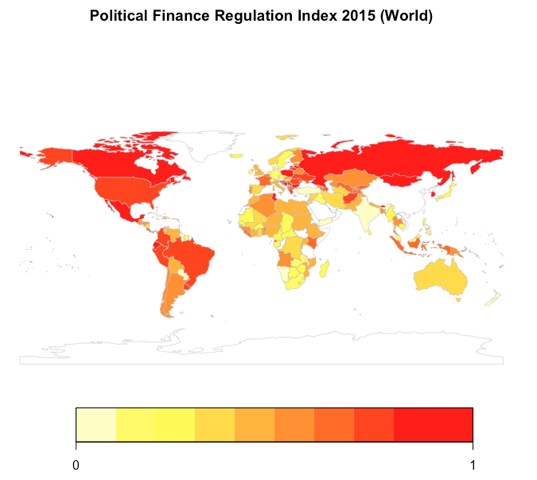

Figure I. Worldwide levels of PFR 2015 (source: own calculations)

The yearly increase of regulation is evident in Figure z, which shows the changes over time of the PFR Index. This figure displays an increasing trend in the regulation effort in all regions. The slope of the time series remains positive for the period 1996-2005, increasing its steepness after 2006. Europe is the region that increased its party finance regulation the most, implementing 55% of regulations, with notable growth after 2010. The Americas and Asia are the second and third place respectively in terms of adoption of regulations.

Figure II. PFR Index times series by regions, 1996-2015: America, Europa, Africa, Oceania, and Asia

The increase of party finance regulation has not been reflected in control of corruption. Figure z displays the increasing trend in PFR but also shows that the average of the CoC Indicator has stagnated and even showing a slight downward trajectory. The evolution of both time series suggests that the increased political finance regulation efforts made by different countries around the globe is not associated with an overall improvement in the control of corruption.

Figure III. PFR and WB Control of Corruption Index time series, 1996-2015 (Source: own calculations)

The overall increase in PFR is reflected in all of the categories of the IDEA Political Finance Database, although there are some small differences to note. XX graph shows that the regulation area that has increased the most in relative terms in all regions is oversight and sanctions, while the least has been public funding. Nonetheless, the figure displays that all the sub-indexes have increased systematically since 1996. This reflects a widespread trend around the world to increase party finance regulation in a comprehensive manner, including regulations across the whole spectrum.

Figure IV. PFR Sub-Index level in 1996 and 2015 by region. BLPI: Bans and limits on private income, PF: Public funding, RS: Regulation on spending, OS: Oversight and sanctions (source: own calculations)

## Political Finance Regulation and Control of Corruption in LA

The worldwide increase in PFR is also reflected in the Latin American region. Figure xx shows that most countries have from a medium to a high degree of PFR. However there are exceptions like Bolivia, Venezuela and Paraguay, with low levels of PFR. Of our countries of interest, Mexico has a high level of regulation, while Argentina and Chile have medium levels. The following sections include different figures with different time periods, either 1996 to 2015 or 2006 to 2015. This is aimed at maximize the clarity of the changes over time of the different variables.

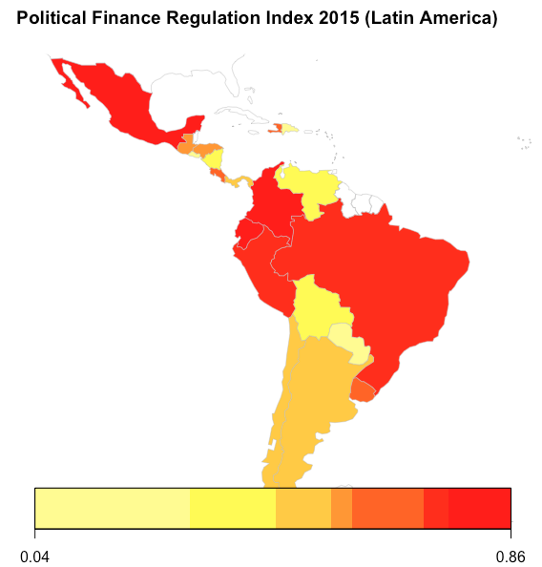

Figure V. PFR Index in LA 2015 (Source: own calculations)

Following the worldwide trend, Figure xx shows the evolution for the Party Finance regulation Index and its subcomponents for Latin America. The regulation category that increased the most is *oversight and sanctions*. In second place appears *regulation on spending*, followed by *bans and limits on private income* and *public funding*.

Figure VI. PFR Sub-index time series in 1996 and 2015 for Latin America. BLPI: Bans and limits on private income, PF: Public funding, RS: Regulation on spending, OS: Oversight and sanctions (Source: own calculations)

In the same sense, Figure xx shows the levels of the PFR Index in 2006 and 2015 for Latin American countries included in the sample. Results indicate that Ecuador is the country with the biggest increase in party finance regulation, followed by Mexico and Colombia. On the contrary, Paraguay and Dominican Republic show no change in the Index.

Figure VII. PFR Index level in 2006 and 2015, Latin America (Source: own calculations)

As with the rest of the world, an increase in PFR is not reflected on the CoC Indicator. Figure VIII shows the average change in the level of political finance regulation for Latin America and the average change of the CoC Indicator from 1996 to 2015. The Figure also shows that while the CoC Indicator slightly improves for the period 1996-2010 in Latin America, this is reversed after year 2011 with a strong deterioration of the levels of corruption.

Figure VIII. Mean PFR Index and World Bank Control of Corruption time series in 2006-2015, Latin America (Source: own calculations)

The data shows that countries that increased most their regulation between 2006 and 2015 are Ecuador, Mexico and Colombia, which is represented in Figure IX. This suggests that among the aforementioned countries, increases in legislation are not always correlated with a reduction in the control of corruption. Ecuador seems to be the exception by showing an improvement in its control of corruption. In addition, Guatemala, Honduras and Uruguay have also shown improvements on their levels of control of corruption in the last decade.

Figure IX. PFR Index and World Bank Control of Corruption change in 2006-2015, Latin America (Source: own calculations)

The relation between CoC and PFR is complemented by the WEF Judicial Independence Indicator as it is illustrated in Figure xx. The first thing we can observe is that, among all Latin American countries, there are three achievers in CoC: Chile, Uruguay and Costa Rica. These countries also have the highest score of judicial independence. Within this group, we can also see that while Uruguay and Costa Rica made a significant amount of in law effort regarding political finance regulation from 2006 to 2015, Chile did not increase at their pace. Also, Uruguay and Costa Rica improved their scores of CoC, while Chile´s worsened. This suggests that countries with high levels of judicial independence, higher political finance regulation leads to an increase of control of corruption.

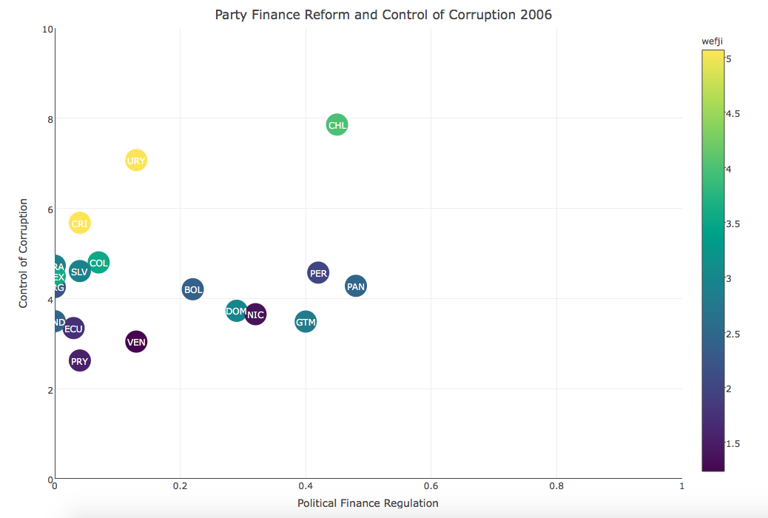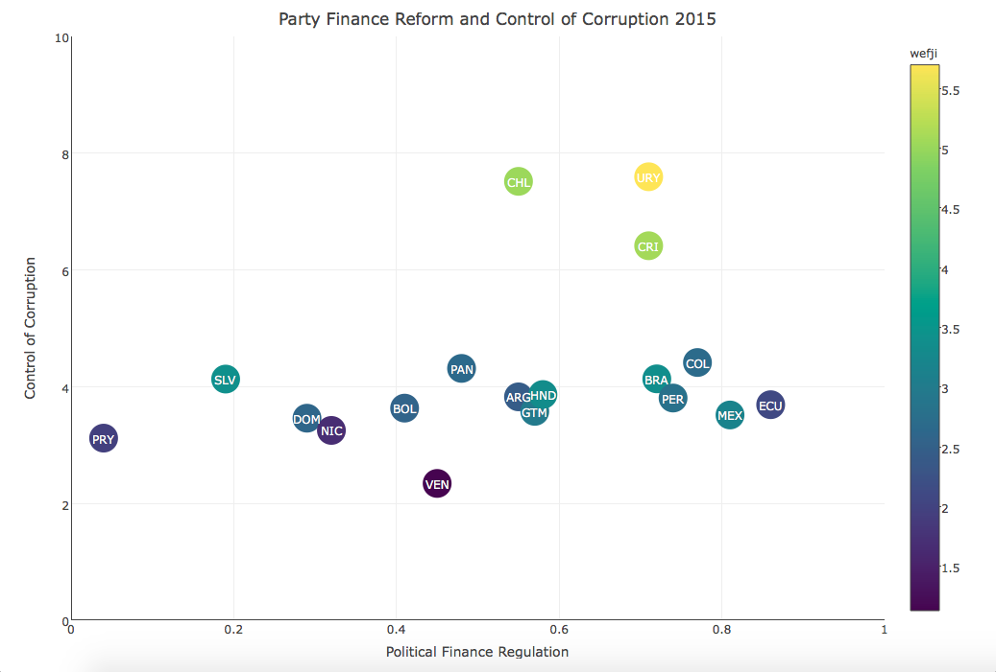

Figure 10. CoC and PFR Scatterplot 2006 and 2015 (Source: own calculations)

## Panel regression model of Latin America

To further explore the relationship between control of corruption, political finance regulation and judicial independence, it is necessary to rely on inferential statistics, allowing us to further include other variables like public investments, as well as control for level of development. As stated, this analysis only includes 18 countries of Latin America and has a time span of ten years, from 2006 to 2015.

### Variable description

As explained in the methodology chapter and have been used previously, our dependent variable will be control of corruption, while our independent variables will be political finance regulation, public investment and judicial independence, using the indicators that were previously explained. The regression model will intentionally resemble the equilibrium model described in the theoretical section of this study. In addition, we will include percentage of rural population and life expectancy as control variables for the level of development of the countries.

### Simple regression model

Table I shows the simple regression model, where results (1) to (9) are estimated using pooled OLS, Fixed effects (FE) and Random effects (RE). The equations for these regressions are the following:

$$CoC_{ij}=β_{0}+β_{1}(PFR_{ij})+ϵ_{ij}$$

$$CoC_{ij}=β_{0}+β_{1}\left({PI}_{ij}\right)+ϵ_{ij}$$

$$CoC_{ij}=β_{0}+β_{1}({IJ}_{ij})+ϵ_{ij}$$

The first equation represents (1) to (3), the second (4) to (6) and the third (7) to (9). With respect to the results, party finance regulation has a positive significant effect on control of corruption in a pooled OLS model. Interestingly, this result is reversed when accounting for the idiosyncratic characteristics of each country in panel estimations. Public investment and judicial independence both have the expected signs, negative and positive, respectively. Thus, an increase in the level of public investment is associated with deterioration in the control of corruption; on the other hand, increases in judicial independence are correlated with improvements in the dependent variable. Both regressors are statistical significant at usual levels of confidence.

|  |  |  |  |  |  |  |  |  |  |
| --- | --- | --- | --- | --- | --- | --- | --- | --- | --- |
|  | OLS | FE | RE | OLS | FE | RE | OLS | FE | RE |
|  | (1) | (2) | (3) | (4) | (5) | (6) | (7) | (8) | (9) |
|  |  |  |  |  |  |  |  |  |  |
| PFR | 0.750*** | -0.0649 | -0.0601 |  |  |  |  |  |  |
|  | (0.205) | (0.0491) | (0.0494) |  |  |  |  |  |  |
| PI |  |  |  | -0.265 | -0.496** | -0.49** |  |  |  |
|  |  |  |  | (0.503) | (0.230) | (0.228) |  |  |  |
| JI |  |  |  |  |  |  | 0.546*** | 0.0608** | 0.151*** |
|  |  |  |  |  |  |  | (0.0229) | (0.0300) | (0.0310) |
| Cons. | -0.63*** | -0.27*** | -0.277* | -0.27*** | -0.25*** | -0.264 | -1.96*** | -0.48*** | -0.76*** |
|  | (0.103) | (0.0232) | (0.158) | (0.0637) | (0.0190) | (0.171) | (0.0741) | (0.0918) | (0.124) |
|  |  |  |  |  |  |  |  |  |  |
| Obs. | 180 | 180 | 180 | 178 | 178 | 178 | 179 | 179 | 179 |
| R-sq. | 0.070 | 0.011 |  | 0.002 | 0.028 |  | 0.763 | 0.025 |  |
| N |  | 18 | 18 |  | 18 | 18 |  | 18 | 18 |

Table I. Simple Regression Model. Standard errors in parentheses, *** p<0.01, ** p<0.05, * p<0.1

### Multivariate regression model

To better reflect the equilibrium model, a multivariate regression is needed. The multivariate regression model is estimated in equations (1) to (9). Results for pooled OLS, Fixed effects (FE) and Random effects (RE) are presented. Several results are presented to assess the robustness of the analysis.

The regression model for equations (1) to (3):

$$CoC_{ij}=β_{0}+β_{1}\left(PFR_{ij}\right)+β_{2}\left(PI_{ij}\right)+β_{3}\left({JI}_{ij}\right)+ϵ_{ij}$$

The regression model for equations (4) to (6):

$$CoC_{ij}=β_{0}+β_{1}\left(PFR_{ij}\right)+β_{2}\left(PI_{ij}\right)+β_{3}\left({JI}_{ij}\right)+β_{4}(PFR_{ij})(JI_{ij})+β_{5}(PI_{ij})(JI_{ij})+ϵ_{ij}$$

The regression model for equations (7) to (9):

$$CoC_{ij}=β_{0}+β_{1}\left(PFR_{ij}\right)+β_{2}\left(PI_{ij}\right)+β_{3}\left({JI}_{ij}\right)+β_{4}\left(PFR_{ij}\right)\left(JI_{ij}\right)+β_{5}\left(PI_{ij}\right)\left(JI_{ij}\right)+RP_{ij}+LE_{ij}+ϵ_{ij}$$

The results reflected in Table II show that increases in political finance regulation are related with a deterioration of control of corruption in Latin America. This relationship is statistically significant in the panel estimations.

Inversely, the negative relationship between regulation and control of corruption becomes positive in countries with high levels of judicial independence. Furthermore, for countries with high levels of judicial independence, an increase in regulation has a positive effect on control of corruption.

|  |  |  |  |  |  |  |  |  |  |
| --- | --- | --- | --- | --- | --- | --- | --- | --- | --- |
|  | OLS | FE | RE | OLS | FE | RE | OLS | **FE** | RE |
|  | (1) | (2) | (3) | (4) | (5) | (6) | (7) | **(8)** | (9) |
| **PFR** | -0.0601 | -0.0131 | -0.0078 | -0.81*** | -0.353** | -0.380** | -0.302 | **-0.309\*\*** | -0.320* |
|  | (0.121) | (0.0567) | (0.0625) | (0.306) | (0.150) | (0.164) | (0.241) | **(0.140)** | (0.170) |
| **PI** | -0.287 | -0.551** | -0.635** | -0.879 | -3.53*** | -3.31*** | -8.00*** | **-2.37\*\*** | -3.41*** |
|  | (0.268) | (0.271) | (0.287) | (1.208) | (0.984) | (1.057) | (1.105) | **(0.936)** | (1.100) |
| **JI** | 0.551*** | 0.0691** | 0.147*** | 0.419*** | -0.0299 | 0.0365 | 0.258*** | **0.0309** | 0.0971** |
|  | (0.0253) | (0.0300) | (0.0309) | (0.0545) | (0.0345) | (0.0366) | (0.0424) | **(0.0385)** | (0.0394) |
| **JI×PI** |  |  |  | 0.189 | 0.902*** | 0.819*** | 1.914*** | **0.673\*\*** | 0.844*** |
|  |  |  |  | (0.353) | (0.279) | (0.301) | (0.304) | **(0.262)** | (0.310) |
| **JI×PFR** |  |  |  | 0.258*** | 0.110*** | 0.119*** | 0.108 | **0.108\*\*\*** | 0.0969** |
|  |  |  |  | (0.0946) | (0.0413) | (0.0455) | (0.0729) | **(0.0393)** | (0.0471) |
| **LE** |  |  |  |  |  |  | 0.031*** | **-0.073\*\*** | -0.031* |
|  |  |  |  |  |  |  | (0.00810) | **(0.0239)** | (0.0178) |
| **RP** |  |  |  |  |  |  | -0.02*** | **-0.011** | -0.02*** |
|  |  |  |  |  |  |  | (0.00218) | **(0.0106)** | (0.00519) |
| **Cons** | -1.93*** | -0.45*** | -0.69*** | -1.56*** | -0.146 | -0.354** | -2.66*** | **5.378\*\*\*** | 2.351* |
|  | (0.0797) | (0.0911) | (0.125) | (0.156) | (0.106) | (0.141) | (0.613) | **(1.937)** | (1.349) |
| **Obs** | 177 | 177 | 177 | 177 | 177 | 177 | 160 | **160** | 160 |
| **R2** | 0.760 | 0.060 |  | 0.770 | 0.189 |  | 0.880 | **0.264** |  |
| **(n, T)** |  | (18, 10) | (18, 10) |  | (18, 10) | (18, 10) |  | **(18, 10)** | (18, 10) |

Table II. Multivariate regression model. Standard errors in parentheses. *** p<0.01, ** p<0.05, * p<0.1

The marginal effects plot in figure X illustrate this relationship and uses the following equation:

$$\frac{dCoC_{ij}}{dPFR_{ij}}=β_{1}+β_{4}\left(JI_{ij}\right)=-0.3+0.18(JI_{ij})$$

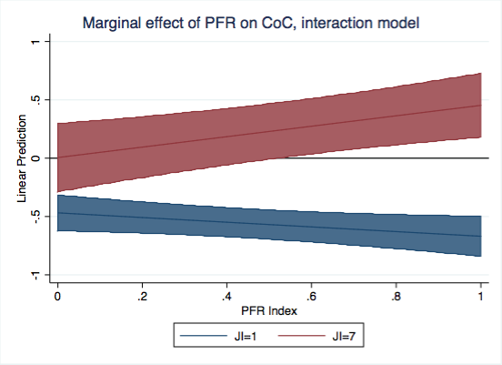

Figure XI. Marginal Effects of PFR on CoC for different levels of JI (Source: own calculations)

In a similar way, increases in opportunities to corrupt, represented by levels of public investment, have a significant and negative effect in control of corruption. This relationship is also reversed for countries with high levels of judicial independence. Figure XI illustrates this by using this equation:

$\frac{dCoC_{ij}}{dPFR_{ij}}=β_{2}+β_{5}\left(JI_{ij}\right)=-2.37+0.67\left(JI_{ij}\right)$ 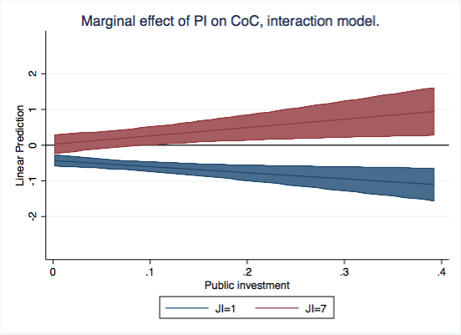

Figure XII. Marginal Effects of PI on CoC for different levels of JI (Source: own calculations)

Furthermore, Figures XII clarifies the relationship between predicted and actual values of CoC for Latin America. According to our equilibrium model, CoC values for Chile are significantly above predictions, while in Argentina and Mexico they are below the expected values considering the levels of all the other variables.

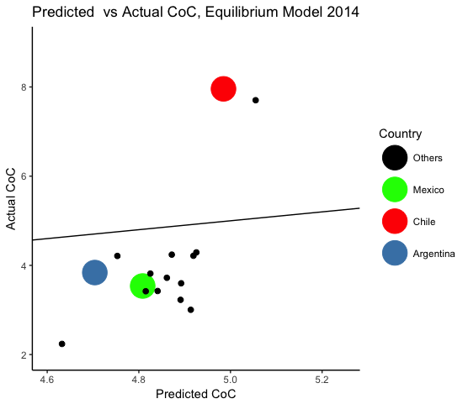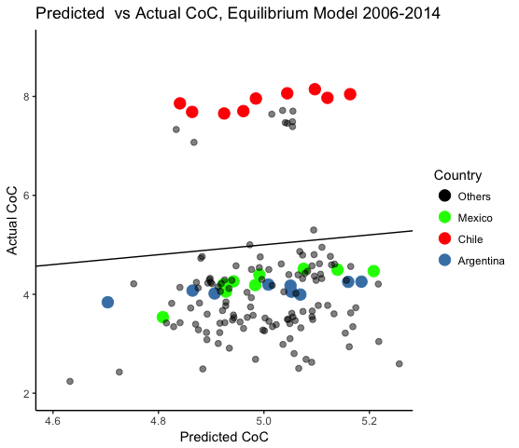

Figure XIII. Predicted vs. Actual CoC. Equilibrium Models 2014 & 2006-2014. (Source: own calculations)

Beyond the robustness of our regression’s results, it is necessary to dive a bit deeper to understand how the different variables of our model should be balanced in order to reach a better equilibrium in CoC within a particular country in Latin America.

In-law efforts in terms of PFR are effective only there where JI is high. As graph XX shows, the marginal effect of passing new political finance legislation is significant when JI has a high level and PFR is substantial, meaning that it regulates over 50% according to the PFR Index. Conversely, in those countries with low levels of JI, adding new rules to the realm of political finance is even self-defeating, since control of corruption keeps deteriorating.

On the other hand, Graph XX illustrates a very similar dynamic between control of corruption, judicial independence and public investment. In countries with weak JI, the marginal effect of increasing PI influences CoC negatively. Conversely, when JI is high, increasing PI does not necessarily extent opportunities to corrupt not affecting CoC.

## How to improve control of corruption in Latin America?

Conclusively, the main results of the quantitative analysis confirm that in Latin America, when it comes about CoC, judicial independence is the key variable. Table XX highlights negatives correlation between PFR and CoC, as well as between PI and CoC. This means that, within our sample of countries and according to data, increasing PFR and/or PI is significantly correlated to worse performance in CoC. However, when both variables are separately interrelated with JI, the correlation with CoC*´s* change turn*s* into positive. This means that JI is central for the effectiveness of PFR and PI with regard to of CoC. Even more, considering that JI has no significant correlation with CoC by itself.

According to the theoretical framework, societal control of corruption is the result of the interaction between opportunities and resources to corrupt and different kind of institutional and social constraints. This equilibrium model theory suggests that improvements in control of corruption “can occur only gradually and through a succession of radical actions and disequilibria until a new equilibrium is achieved with a superior control of corruption” (Mungiu-Pippidi 2015, p. 211) Therefore, domestic agency tends to be more effective than external governance strategies, and the particular context of a country is highly important to draft interventions in order to improve control of corruption. (Mungiu-Pippidi 2015)

Besides this, the few countries which developed successful strategies to fight corruption applied their own models of state building, but they also followed others fruitful models when it was required. (Mungiu-Pippidi 2015, p.216) With that in mind, we will focus on how to improve CoC in each of our study cases: Argentina, Chile and México.

Considering the governance contexts of these nations, we will analyse how each country has been performing in CoC as part of Latin America. The analysis will follow the explanatory variables set in this quantitative part. Based on the results, as well as, on the best performers in Latin America, we will present some guidelines to improve control of corruption in Argentina, Chile and México.

# 5. Studies of Argentina, Chile and Mexico

The following section is comprised of analyses on changes in control of corruption, political finance regulation, judicial independence and public investment in Argentina, Chile and México, as well as the exploration of some guidelines to improve control of corruption in the three countries.

## Argentina

Argentina is a constitutional democracy organized as a federation of 24 political sub-unities: 23 provinces and the Autonomous City of Buenos Aires. It´s governmental scheme is a presidential system, which has been ruling uninterruptedly since 1983, when the last military dictatorship was overcame. In 2015 the country registered a population of 43.4 million of people and a GDP of 583 billion U$S. Its life expectancy was over 76 years old and it had a GNI of 12.5 thousand U$S. Within its region, Latin America[1], Argentina is the third biggest economy and the fourth most populated territory. (World Bank 2017)

### Corruption Context

Corruption has been one of the main concerns of Argentina´s inhabitants during the last decade. Even with an ongoing economic crisis, in 2016 people considered corruption one of the most relevant problems of the country. (Latinobarómetro 2017) In line with this, a local survey made in 2013 showed that 86% of Argentinean inhabitants qualified corruption among the society as “high” (56%) or “medium” (30%) and only 13% considered it “low”. Furthermore, corruption was believed endemic and widespread in all public areas, affecting the political sphere in particular. (Universidad de Belgrano 2013)

Global perception indicators are aligned with those results. The Corruption Perception Index of Transparency International, which measures how corrupt the public sector of a country is seen to be, placed Argentina 95out of 176 countries with a score of 36 out of 100. It also states that in 2016 Argentina improved 3 points compared to 2015, but only 1 point since 2012. (Transparency International 2016)

Furthermore, the International Country Risk Guide produced by the PRS Group, highlighted corruption as one of the most critical factors of the country political risk by January 2015. (The PRS Group 2015) Finally, the Worldwide Governance Indicators projects points out that the lack of control of corruption among the Argentinean public powers ranks 68 out of 208 countries, situating Argentina within the third of the most corrupt countries in the world. (Kaufmann et. al. 2010)

Despite its long relevance, in the last five years, corruption turned into one of the most prominent issues of concern in Argentina. The reason for that was the emergence of renowned cases of corruption which involved the highest levels of the public and private sectors. For instance, while the current president and his father are being investigated by the local justice due to serious links to the Panama Papers scandal (La Nación 2017), the former president and vice-president are being prosecuted for embezzlement. In addition to that, the former Minister of Public Infrastructure and Federal Investment was charged in 2016 with the crime of misappropriation of federal resources and one of his closest assistants, the former Secretary of Public Infrastructure was arrested in June 2016 while he was trying to hide 9 million of undeclared U$S into a monastery. (La Nación 2016)

All things considered, we can observe that Argentina presents many characteristics of “competitive particularisms” governance regimes. (Mungiu-Pippidi 2015, p. 29) For instance, power is stratified but disputed competitively; State´s autonomy tends to be captured by those who win the elections; public allocation of resources is particular and mainly dependent on the governing party; the separation between public and private sectors is weak and sometimes inexistent; and government accountability tends to be possible only when ruling parties change.

### Argentina´s performance within Latin America

Based on our model, now we are going to analyse how Argentina has been performing as part of Latin America. Table XX provides a first glance of the country´s performance from 2006 to 2015 in absolute and relative terms.



Control of Corruption in Argentina has been deteriorated by almost 60% between 2006 and 2015, when it reached its worst score from the last ten years. Despite it had some improvements between 2010 and 2013, as Table XX shows, Argentina could never reversed CoC´s downward trend for more than two successive years. These absolute numbers are important, because we can also appreciate that in 2015 Argentina ranked better than in 2006 compare to the rest of Latin America. However, this only means that other countries have been performing even worse than Argentina.

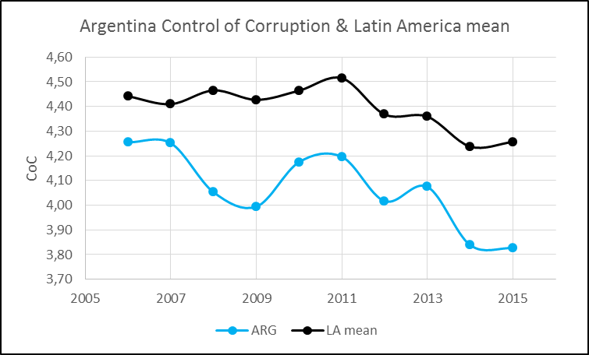

Regarding Party Finance Regulation we can see that Argentina did a significant in-law effort in 2009 which led it from the last positions within Latin America to the 6th place in the ranking.

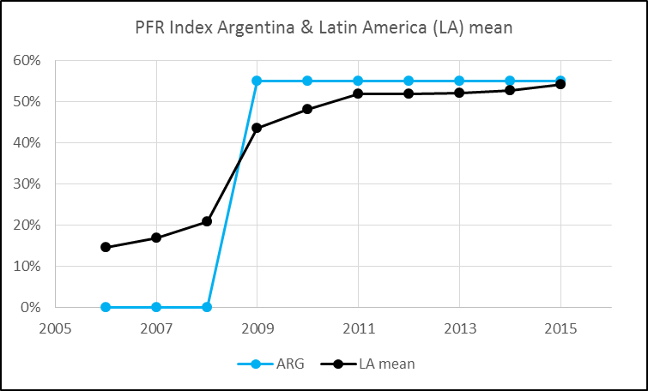

Going into detail, Graph X shows that the category *oversights bodies and sanctions* was the strongest regulated (71%) in relative terms, followed by *bans and limits on private income* (50%) and *public funding* (40%). On the other hand, *regulation on spending* kept as the weakest delimitated category (25%). Beyond the particularities of this regulation, it is interesting to remark that one year after this legal reform in political finance passed, CoC improved. Nevertheless, afterwards it never stopped decreasing and in 2015, Argentina ranked 10 out of 18 countries in terms of PFR. After 2009 the country passed no other regulation on the topic, meanwhile other countries in Latin America did.

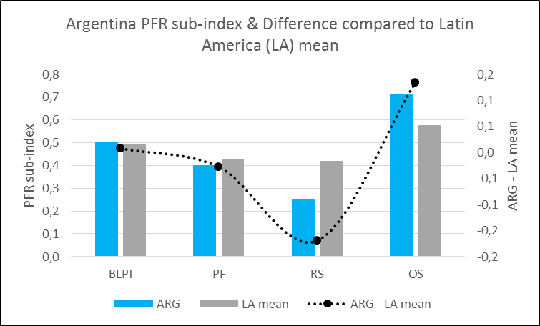

Judicial Independence, the other analysed constraint of corruption, confirms a dramatic scenario. From 2006 to 2015 Argentina could never integrate the first half of best performing Latin American countries. Indeed, despite doing better in absolute terms, the country moved back from the position 13th in 2006 to the 14th in 2015, being in the limit of the worst performers quartile.

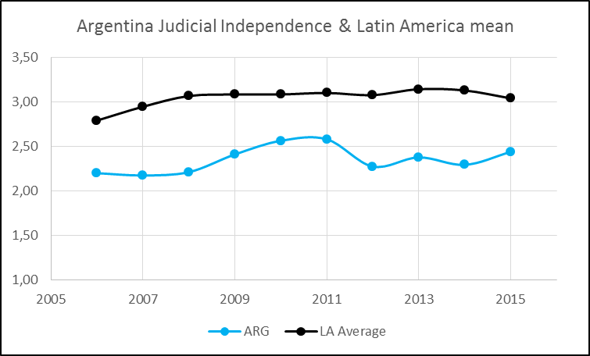

Finally, Public Investments, the main opportunity to corrupt that we considered shows that public investment in Argentina has been relatively low in terms of percentage of the GDP. As we can observe in Table XX it increased less than 0,3% from 2006 and 2015. It had a visible rise in 2014 going back to its normal range the next year. Following the theory, we can presume the existence of corruption in public capital expenses in 2014 in order to finance the electoral campaign in 2015. Going back the variable, besides its PI% over GDP, in absolutes terms the country has been part of the first quartile of countries with the highest public capital expenses.

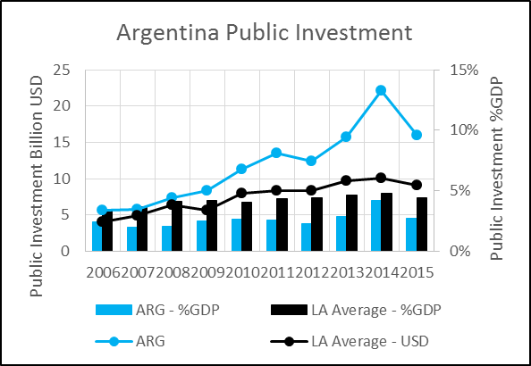

### The strategy to improve control of corruption in Argentina

Based on these results, now we are going to illustrate the specific balance of our equilibrium model in Argentina compared to the three best performers -Chile, Costa Rica and Uruguay- and the Latin American media. Our goal is to identify the strengths and weaknesses of the Argentinean case in order to build a control of corruption strategy, based on the best performers´ experiences and taking into account the local context.

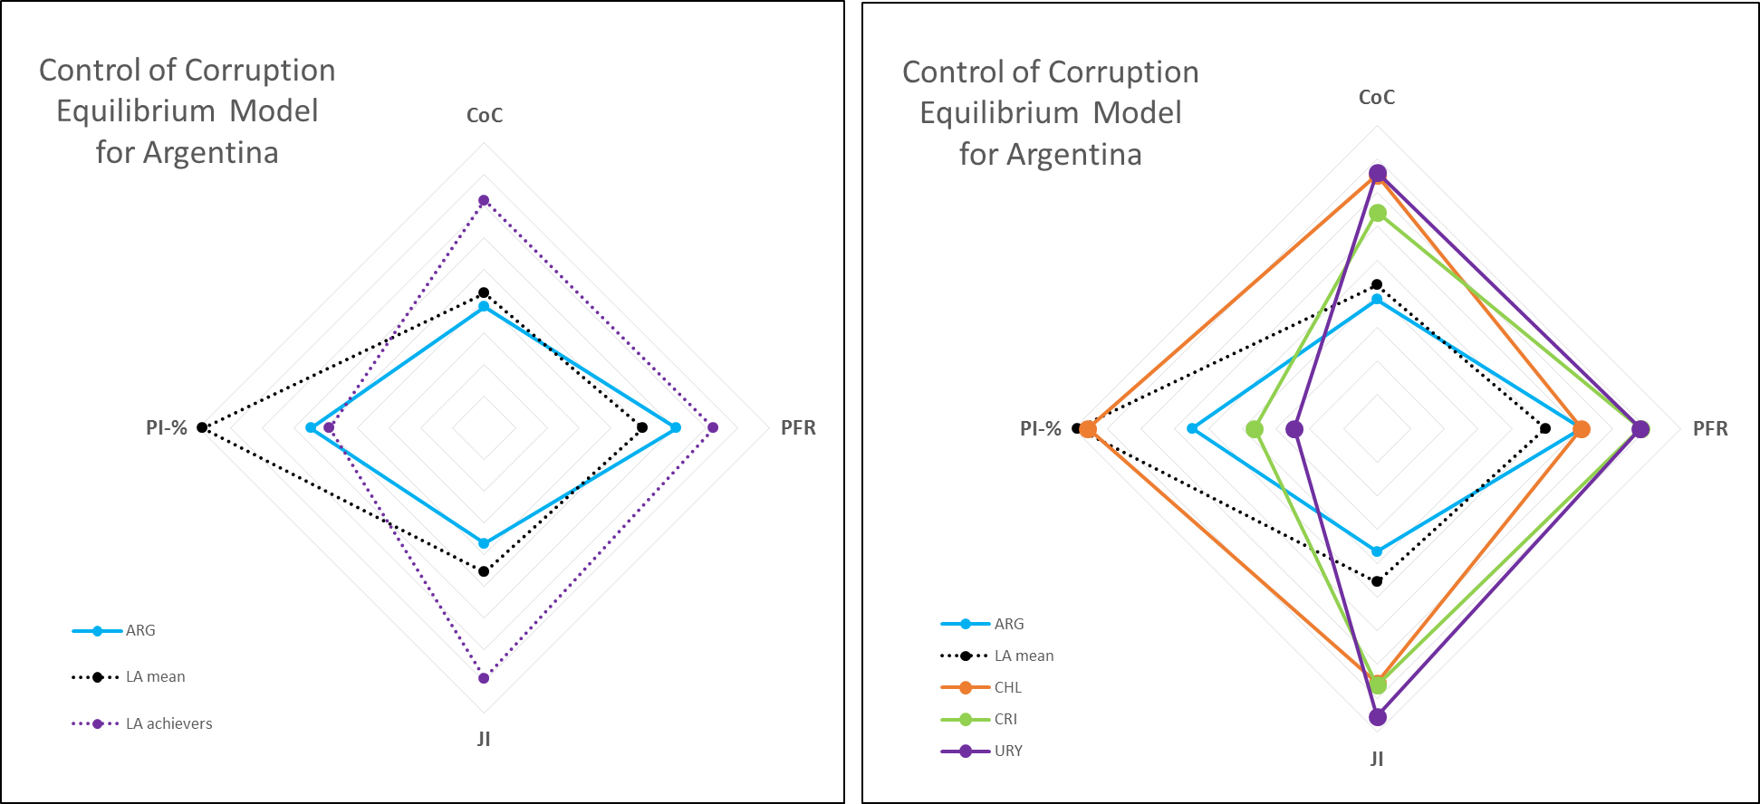

Firstly, Figure XX enlightens that, as we already knew, Argentina is performing even below the LA media in CoC and the reason is undisputable. While the three main achievers managed to develop high levels of judicial independence, Argentinean performance is one of the worsts in the region, below the media.

The rest of the picture provides also shows that Uruguay and Costa Rica have high scores in PFR, while Chile is at the same level than Argentina and in line with the LA media. This should be considered together with results of Table XX (LatAm Correlation) and the conclusions of Figure XX (gráficos 2006/2015 cambio variables países LatAm). By doing that we can mention that increasing PFR can have positive effects over CoC, but only if the judiciary is really independent.

Finally, concerning public investment, the figure shows that two out of the three achievers assign a lower percentage of funds to public investments than Argentina. However, Chilean capital expenditures exceed Argentinean ones by far, being at the same level than LA. This scenario is in line with the observation that, as long as a country has high judicial independence, PI% over GDP does not affect CoC negatively.

Overall, our strategy for Argentina to improve its performance in control of corruption will be primarily based on enhancing judicial independence. Afterwards, since those changes take time, we will focus on how to improve public investment procedures in order to discourage corruption. Finally, we will identify some positive options regarding better political finance regulations. This is also important for two reasons. Firstly, complete strategies include long-term recommendations. Secondly, a relevant discussion about how to improve PFR is taking place at the national level.

### Judicial Independence

This topic has been permanently debated in Argentina since the recovery of the democracy in 1983. However, in the las years it gained significant relevance due to a combination of political decisions made by the former and the current governments and the rise of a set of serious problems like, for instance, corruption. (Poder Ciudadano 2016)

The lack of judicial independence in Argentina is said to be rooted in the early constitutional decision made by the Latin American founding fathers, aimed at creating an institutional system of *checks and balances* combined with a strong *presidentialism* capable, at that time in history, to guarantee the unity of the three public powers. However, from that moment on, this decision enable Governments to rule over Judiciaries and the Parliaments in most of the region. Hence, to improve judicial independence, it is considered necessary to balance the influence of the three powers, together with new mechanisms to enhance real participation of citizens in judicial processes. Costa Rican and Colombian *tutelas,* for example, are considered successful tools to improve access to justice and judicial independence. (Gargarella 2016)

More in detail, scholars highlight two current problems which are seriously affecting judicial independence in Argentina. First, the paralysis of the Argentinean Judicial Council -*Consejo de la Magistratura-* created in 1994 to appoint national judges in order to reduce undue influences of governments over the judiciary. However, in 2006 the ruling party managed to increase government´s power within this body. After that, processes to appoint judges and disciplinary process were almost frozen. The second problem is directly connected to the previous one and is aimed at the role of substitute judges. To temporally replace non-appointed judges, as well as those who are removed, resignation or retire, law contemplates a specific process which gives higher discretionary powers to the government and exposes temporary judges -*jueces subrogantes-* to stronger influences from the other powers. Indeed, by 2015, almost 20% of the national judges were temporary and 75% of them had no fix term to stop delivering justice. (Herrero & Leonardi 2016; ACIJ 2016)

Additionally, specialists also focus on the process to appoint justices from the Federal Supreme Court. Argentinean Constitution states that is the President who appoints them with the consent of two-thirds of the present members of the Senate. In 2003, the ruling President signed an executive decree which significantly increased transparency in the designation of Supreme Court´s justices by stablishing public audiences to debate their profiles. However, in 2016 the current President appointed two new supreme justices by decree without following the existing process. This was considered a step back in terms of independence of the highest judicial authority in the country. (Saba 2016; ACIJ 2016)

Finally, the lack of transparency and accountability of the judiciary are others obstacles which undermine Argentina´s judicial independence. For instance, the Criminal Code prohibits the publicity of all legal cases, included corruption ones. Moreover, the Supreme Court decided that the regulation which obliges every public servant to disclose their personal patrimony, did not apply to the judiciary. (ACIJ 2016)

Besides all these problems which, according to the local experts, need to be fixed to improve judicial independence in Argentina, now we are going to present some of the main reasons why Latin American achievers are performing so well. The specialized literature remarks that after the recovery of democracy, in the last 30 years, most Latin American countries promoted reform processes of their judiciaries with different results. (Skaar 2003; Inclán & Inclán 2005; Sousa 2007)

Together with Chile and Costa Rica, Argentina´s reform is considered “far-reaching”, since it covered an important number of issues. However, while in Costa Rica population´s trust in the judiciary was high, in Argentina was the worst among Latin America. Going in-depth, when it comes about the obstacles for judicial independence, in Argentina the problem seems to be the strong influence of the Executive Branch. Conversely, in Chile and Costa Rica, that is not an issue. The dependence is mainly hierarchical, meaning that the Judiciary is not influenced by Governments or Parliaments but, within its structure, judges are subject to their superiors. (Popkin 2004; Sousa 2007)

Moreover, unlike Argentina, the Costa Rican Executive power and Congress have no influence over Judicial Council members´ designation. Furthermore, while comparing judicial reforms in Latin America, certain items like quality, education, responsibility and transparency of the judiciary appear to be those topics in which Chile and/or Costa Rica are performing better than Argentina. (Sousa 2007) For instance, the creation of a Judicial Academy, which plays a key role in training future judges, had very positive results in Chile. (Popkin 2004)

Finally, scholars conclude that success and profit from judicial reforms in Latin America have been related to transparent and participatory reforms, adjusted to social, economic and political local contexts. For example, the Committee of Ethic for the Judiciary created by the Chilean Supreme Court and the use of internet to guarantee public access to most of the judicial information adopted by the Supreme Court from Costa Rica, are highlighted as two positive measures to increase transparency and accountability and to reduce corruption within the judiciary. (Popkin 2004; Sousa 2007)

Another difference regarding successful reforms of the judiciary is the gap between formal and real judicial independence. Argentina performs worse than Chile and Costa Rica in both realms, and worse than Uruguay also in real judicial independence. (Sousa 2007) Political parties´ commitment to assure real judicial independence is another issue which differentiates Chile from Argentina. In Chile, the two biggest political parties agreed on providing real independence to the Supreme Court and this lead to positive results. In Argentina, during the times of the reform, this did not happen. (Skaar 2003)

Finally, regarding Uruguay, scholars observe that its judicial reform was more superficial than the Argentinean and Chilean ones, mainly because, unlike its neighbours, Uruguay had no economical, historical or social incentives to drive the reform. (Skaar 2003) Nevertheless, Uruguayan Judiciary has been considered one of the most independent in Latin America. Practitioners remark the merit-based professional career within the judiciary as the key pillar of the system, which allows judges to make decisions against ruling politicians. (Miguel Loinaz 2015)

Concerning the current balance of power and the contextual stakeholders map, it is important to mention that today Argentina presents a window of opportunity to foster judicial independence. Since long, the civil society has recognized the relevance of judicial independence for democracy and in particular, to improve the rule of law and reduce corruption. In the early 2000 the civil society built up the movement called *“A Supreme Court for Democracy”* to protest against a Supreme Court completely dependent on the Government.Its role was key for the renewal of many justices and for the adoption of the transparency rules above mentioned. Nowadays, in a different context, a new coalition of NGOs has just been created with the goal of fostering reforms to enhance judicial transparency, impartiality and independence. Its name is *“Coalition for the Judicial Independence”* and gathers some of the most active organisations in this field. (La Nación 2015)

### Public Investment Control

Judicial independence reforms are not easy and take long. Therefore, according to our quantitative analysis, in the meanwhile Argentina needs to reduce corruption opportunities concerning public investment. The current scenario is alarming. Like we saw, PI% over GDP in Argentina exceeds Uruguayan and Costa Rican ones.

However, unlike almost all Latin American countries, Argentina has no public procurement law. Public purchases are ruled by a presidential decree from 2001. Even worse, this regime does not reach public infrastructure contracts, which are still ruled by a law from 1947. In the region, only Chile and México have the same regulatory framework. Besides this, the Argentinean norm authorizes direct contracting in unjustified situations and the practice confirms an abuse in the use of exceptions to apply this tool. Moreover, conflict of interest is poorly regulated too; former public officials, civil servants, their relatives and close friends and private societies managed by them, are not disabled to contract with the state. Finally, the organisms created to rule the public procurement system is not independent and has no control and punishment competences. (Volosin 2016)

The information related to public procurements tenders is also very limited. The official website of the Argentinean Infrastructure Ministry, for instance, only publishes the call for applications, but there is no processed information about the selected companies. The only option to identify the winning companies is analysing the Official Gazette daily. Also, there is a National Office of Public Purchases. Nevertheless, the data available today is from 2006 to 2012, and the public procurement tenders are not registered.[2]

The best example of the discretion which rules these areas may be what happened in 2015, when the Minister of Public Infrastructure decided to publish the list of the top 40 private services providers to the state. It was a unilateral decision considered a replay to a corruption accusation. The methodology behind the list was never revealed and the outcome was seriously criticised by some specialists. (Bidegaray 2015)

Looking for good practices among Latin American achievers, the adoption of technology by the Chilean government in the ´90, in order to make pharmaceutical purchasing more transparent, is considered a successful case which improved savings and the access of poor people to essential medicines. The salient element was the implementation of an electronic bidding system which opened drug prices information to all the participants, reducing the risk of collusion among suppliers. (Cohen & Montoya 2001)

That trend was deepened in 2003 whit the launch of *ChileCompra,* a new system identified as the main regional example of public purchasing modernisation aimed at enhancing transparency, preventing corruption and guaranteeing public accountability. Mainly, this program included the creation of a unique organism which centralizes all public purchases, a website to facilitate the interaction between the State and its private suppliers and a register of public suppliers in order to gather all the information and to reduce paperwork in bidding processes. (Capello & García Oro 2015)

The use of websites by official institutions has also been highlighted in terms of transparency and public accountability in Uruguay. The improvement in the role played by the National Internal Audit Office was underline too. Besides that, the Law of Access to Public Information adopted in 2008, and particularly its mandatory trainings for public servants, were positively weighted. Finally, in Uruguay, popular perception regarding how much the fight against corruption had improved grew from 22% in 2004 to almost 60% in 2009. In that period, certain regulations, like a Public Procurement Code and a Public Procurement Disclosure Obligation, were adopted. (Martínez Matute 2013)

### Political Finance Regulation

In 2009, Argentina had parliamentary elections and the governing party lost. After that, the government succeeded in passing the Law 26.571 which modified the ruling political finance legal framework. This new law was presented as a step forward in terms of electoral equity and party finance transparency. However, a deeper study shows some shades regarding that assumption.

According to the specialists, the new law has many problems. Actually, instead of improving transparency and equity, this new law created negative incentives which enhance corruption toward the political finance system. For instance, it established a really low limit for private donations which, since companies remain as the main financial supporters, leads them to use illegal methods of funding. Moreover, the new law unified parties´ ordinaries and electoral campaigns bank accounts, increasing the complexity to track deposited money. Also, parties´ own advertising spaces were prohibited, having access only to advertising spaces provided by the State. Furthermore, State advertising is unregulated, which, on the one hand, gives the government the opportunity to use those advertising spaces with electoral goals. On the other hand, it opened a broad margin of governmental discretion to influence the media through the assignment or cancellation of official advertising funds. In addition, the sanctions system concerning transparency and accountability violations is weak and does not affect candidates. Finally, the judiciary has not being complied with the legal deadlines in sanctioning parties at fault. (Ferreira Rubio 2012; Secchi 2015)

Beyond the main weaknesses of the Argentinean political finance system specified by the aforementioned local specialists, there is a general agreement regarding the statement that, in Latin America, the problem is not the lack of regulation but the inability to enforce legal frameworks. (International IDEA 2014) Nevertheless, like the Figure XX shows, Latin American achievers regulate their political finance systems differently than Argentina. Therefore, identifying their strengths could be helpful to confirm which measures Argentina should adopt.

Chile, for example, made all the electoral founding and expenses information public (Poblete 2015) and in 2015, Law 20.860 assigned constitutional autonomy to the Electoral Service, the institution in charge of managing and controlling the elections.

Costa Rica, for its part, eliminated the limits to private contributions but kept the obligation of revealing donations´ origin and amount. This decision linked to a higher and robust control by the electoral body, increased transparency. The punishment regime is also positively pondered in this country. (Brenes Villalobos 2015)

Finally, Uruguay is a particular case. Despite having one of the oldest independent electoral bodies and political parties systems, it passed the first electoral regulation in 2009. The establishment of a subsidy for parties´ permanent activities instead of electoral campaigns, together with the obligation to disclose all the movements of campaigns and parties functioning founds, are seen as two pros of the new Uruguayan legal framework. (Olascoaga 2015)

Today, in Argentina, the government is promoting reform of the electoral system regulation. The adoption of a unique ballot, the simplification of the electoral calendar and the creation of an autonomous body in charge of monitoring the elections, are the key topics under debate. (Müller 2016)

### Specific measures to improve control of corruption in Argentina

Based on the local experts´ analysis and the regional achievers policies aforementioned, these are the most relevant measures to boost control of corruption in Argentina:

**Enhancing judicial independence:** 1) Reduce the influence of the Governments over the Judicial Council; 2) Diminish the time taken by the Judicial Council to appoint new judges; 3) Recover the practice of public audiences for Supreme Court justices appointment and make them less discretionary; 4) Enable more civil society participation in judicial processes; 5) Improve the autonomy of the different stages of the Judiciary from the Government and the Parliament; 6) Develop a stronger merit-based structure within the Judiciary; 7) Require permanent training and education to judicial servants.

**Developing public investments control:** 1) Adopt a modern and comprehensive legal framework which regulates public procurement and public investments in general; 2) Enhance the legal framework which regulates conflict of interest to prevent collusion from former public officials, their relatives and other potential parties; 3) Make private property disclosure rules broader and stricter; 4) Assign independence, control and sanction attributions to the entity in charge of monitoring public procurements; 5) Increase the use of Information and Communication Technology (ICT) to increase transparency and accountability of public procurements and public investments; 6) Apply ICT also, to promote more competition among private suppliers; 6) Promote regular trainings for public servants in order to reduce corruption.

**Improving political finance regulation:** 1) Consolidate the autonomy of the National Electoral Office -the body in charge of programing, organising and executing the electoral regulations- which today depends on the Executive Branch; 2) Increase transparency and accountability of electoral campaigns donations and parties functioning **founds**; 3) Simplify the party finance system to enable money tracking by citizens and control bodies; 4) Reduce Government´s power to influence media and manipulate official advertising; 5) Promote effective punishment for parties, benefactors and specially candidates, in case of non-compliance.

## Chile

## Mexico

Mexico is a federal republic of 32 federal entities located at the north of Latin America. It has an estimated population of over 120 million, which makes it the eleventh most populous country and the most populous Spanish-speaking country in the world, as well as the second most populous country in Latin America, behind Brazil. Mexico is a member of the United Nations, the World Trade Organization, the G20, the Pacific Alliance and a founding member of the Open Government Partnership. Mexico joined the Organization for Economic Co-operation and Development (OECD) in 1994, later joined by Chile, the only other Latin American country in the Organization.

The center-left Institutional Revolutionary Party (PRI) ruled the country from its foundation in 1929 to 2000, when it was defeated by the center-right National Action Party in 2000. The PRI returned to power in 2012 with the election of President Enrique Peña Nieto, whose single six-year term ends in 2018.

Mexico is the second biggest economy of the Latin America and is classified as an upper-middle income country by the World Bank. (World Bank website). It has the fifteenth largest nominal GDP and the eleventh largest by purchasing power parity in the world. Mexico could become the world's seventh largest economy in 2050, but it is decelerating with an annual GDP growth of 2.3 percent in 2016, down from 2.6 percent in 2015. This is due to a global environment of modest growth and stagnant trade. A further economic slowdown is expected from a slowdown of investment from the uncertainty of a potential renegotiation of the North American Free Trade Agreement (NAFTA). However, there is another aspect that obstructs the full economic potential of Mexico. The think thank Mexican Institute for Competitiveness (IMCO) estimates that corruption is costing Mexico from 2 to 9 percent of potential GDP growth.

### Control of Corruption in Mexico

As graph xx shows, Mexico suffered the worst decrease in the region regarding the CoC Indicator from 2006 to 2015. Other evaluations from international organizations go in the same direction. According to the Heritage Foundation, widespread corruption has increased public dissatisfaction. Mexico ranks 123 of 176 in 2016’s Corruption Perceptions Index of Transparency International with a score of 30, a decrease of 5 points and 28 places compared to 2015. In its Integrity Review of Mexico, the OECD warned that if corruption is not tackled effectively, it will be impossible to effectively address many of the other dire challenges facing the country: slumping productivity and competitiveness, stubborn inequality and serious regional security issues. Figure xx shows the fall of Mexico’s CoC Indicator from 2006 to 2015. The country decreased from 4.49 in 2006 in the recoded version of the index to 3.51 in 2015, almost a one-point decrease (half a point with the WB original coding). It also illustrates that this decline is higher than the one observed in the average of Latin America.

In the same sense, public perception about corruption reflects a negative trend. On the National Survey of Quality and Governmental Impact (ENCIG) from Mexico’s National Institute of Statistics and Geography (INEGI) of 2015, corruption is cited as the second most important problem with 51 percent, just behind insecurity and crime. In the survey from 2013, 49 percent reported that they believed corruption was a major issue in their state. Similarly, in the 2015 Latinobarometro survey, only 3.9 percent of Mexican respondents declared having high confidence in government, 17.1 percent some confidence, while 35.2 and 42.4 percent declared having low and no confidence respectively.

The drop in rankings and confidence is related to recent high-profile corruption scandals that have dominated news cycles. In November of 2014, journalist Carmen Aristegui published a report exposing a company with government contracts that owned a mansion designed for the presidential family, described by the First Lady as the “real family home” in a society magazine. In August of 2015, Comptroller Virgilio Andrade, a presidential appointee, cleared the President of any wrongdoing. Two years later, during the signing of General Law of the National Anticorruption System (NACS) in 2016, the President acknowledged that the scandal had hit his government's credibility, but claimed that his family had done nothing illegal. The biggest drop in Figure xx is recorded in 2014, the year of the corruption allegations against President Peña Nieto.

Two of the other most well known cases of corruption are from members of President Peña Nieto’s PRI, although it is worth mentioning that corruption is not limited to that party and there have been corruption escandals of politicians from other parties as well. The former governor of the Tamaulipas state, Tomás Yarrington, was indicted by a jury in the US on charges of drug smuggling, bank fraud, racketeering, money laundering and taking millions of dollars in bribes from the Gulf Cartel and other traffickers since 1998, when he was the mayor of Matamoros. After almost five years on the run, Yarrington was arrested in Italy on April of 2017.

After an investigative report on the website Animal Politico, Javier Duarte, the former governor of the Veracruz state, fled the country at the end of his term in 2016 amongst allegations of corruption, involvement in organized crime and embezzling millions of dollars. Further fueling citizen’s anger, the new governor Miguel Angel Yunes accused Duarte’s government of giving water instead of chemotherapy to children with cancer. A few days later after Yarrington’s arrest, Duarte was apprehended on Guatemala.

The common theme of these cases is that the investigations did not come from the Mexican political system, like oversight authorities or opposition parties, but from other sources, in two cases from the media and in another from judicial authorities from the US.

Aimed at restoring the credibility of the Mexican political system, the aforementioned NACS is just the latest of reforms that aims to fight corruption in the country. According to the OECD, the eight laws that create the System aim to overcome “key shortcomings of the past” by addressing fragmentation in policies, avoiding implementation gaps, improving co-ordination between levels of government, strengthening enforcement mechanisms and reinforcing oversight through greater transparency, expanded auditing powers and involvement of civil society. (OECD report)

Specifically, the laws include a governance structure comprised of a NACS Co-ordination Committee, a Citizen Participation Committee and ethics committees in ministries. They also involve a revamping of codes of conduct for public officials, as well as the federal manual for internal control and risk management standards. Also, they include the development of an online platform comprised of key databases of sanctions and procurement, to support better detection and oversight. (OECD Report)

Furthermore, the law requires that states develop their Local Anti-corruption Systems (LACS) and respective committees. It will oblige more rigorous asset and interest declarations of all officials, and both government employees and firms involved in public sector activities will be subject to a new disciplinary regime for integrity violations. Finally, it demands the enlisting of Specialized Anti-corruption Prosecutors to prosecute acts of corruption. (OECD report)

Nonetheless, it appears that NACS got off on the wrong foot. In April of 2017, the president of the Citizen Participation Committee Jaqueline Peschard denounced that the System was instated without the Specialized Anticorruption Prosecutor, nor the regional authorities in charge of imposing sanctions to public servants that commit serious offenses. Mexico’s main parties did not agree on subject of the Prosecutor, which shows a lack of political will to implement the NACS. (El Financiero)

### Political Finance

Political finance reform was an integral part of the transition of Mexico to a multi-party system. The formulation of some form of public funding for political parties started in the 1960s, but broad political reform was accelerated in the 1990s, during a crisis of credibility of the PRI and the incorporation of the country to NAFTA. The reforms established prohibition to public entities from contributing to political parties and banned contributions by businesses, individuals who live or work outside of Mexico, churches and foreign entities. Moreover, the reforms mandated reports from parties to electoral authorities detailing private contributions and all expenditures. (Reporte chido)

In efforts to further amend the political finance system, comprehensive reforms were passed after 2005, which is reflected in figure xx. The figure displays the sensibility of the PFR Index to the most recent amendments of existing laws. The figure also shows that Mexico has a higher level of regulation than the average of the whole region, an inverse relationship that the one observed on the CoC Indicator.

The reform of 2007, implemented after the contentious 2006 presidential election in which Felipe Calderon became president, altered the financing of political campaigns. It changed the formula for the allocation of public funds to political parties and increased the importance of winning seats, by linking electoral victories to future funding. It also limited private contributions to 10 percent of the total money that was spent in the previous presidential campaign. (CFR)

In a similar way, the most recent political reform of 2014 introduced a new national electoral body to organize elections all over the country and the reelection for Senators and Deputies for up to 12 years. Also, it amplified regulation by increasing the grounds for annulment of election, specifically by exceeding the permitted funding, as well as by expanding the definitions under which a public servant might break electoral rules. Furthermore, it increased the voting choices for Mexicans voting abroad, gender parity rules and increased the threshold of votes for a party to maintain registry and public funding. It introduced the figure of coalition governments and, in response to a push by civil society, independent candidates, who can now participate in elections and receive public and private funds. (Mexico Institute Guide for Mexican elections)

However, political finance reform has been ineffective to counter corruption due to a failure of enforcing the rules and there are no signs that the latest efforts will be any different. Electoral authorities lack the necessary tools to truly monitor the campaign financing process, which could be constituted by illegal campaign contributions at more than four times the legal amounts. (CFR) Also, they fail to address two of the worst problems for democracy in Mexico, vote buying and the infiltration of drug money in campaigns. According to the findings on this study, political finance will only be effective if there are steps taken in regards of the independence of the judiciary.

### Judicial Independence

Parallel to the CoC Indicator, there is a downward tendency on the WEF Judicial Independence Indicator from 2006 to 2015. This tendency is reflected in figure xx and might have be related do with the controversy that has surrounded the three nominations that President Peña Nieto’s made to the Supreme Court. The figure also shows that Mexico is almost in the same level as the region average.

However, the downward trend starts before Peña Nieto’s rise to power. This might have to do with the start of the drug war by former President Felipe Calderon. The inability of the judiciary and police to assume responsibility over security was one of the reasons Calderon decided to use the Army against drug cartels in the country. Calderon often bypassed national courts and extradited drug traffickers to the US almost immediately after being captured. It is worth noticing that the security situation did not improve with President Peña Nieto.

Aware of the problem of the judiciary, Mexican authorities pushed for the most significant change to the system, a 2008 amendment requiring that all state and federal judicial systems transition from a written-based inquisitorial system to an oral-based accusatorial. States that have complied with the reform say that it has helped them with a better allocation of criminal justice resources. However, the reform has been criticized because it does not go far enough in punishing corrupt judges. (Insight Crime)

### Public Investment

The indicator of public investment, which is based on data on capital expenditures of the ECLAC, shows an overall increase of spending in the matter in absolute terms since 2006, as shown on figure xx. Compared with the rest of Latin America, public investment as a percentage of GDP is below the mean, which would be explained by the sheer size of the Mexican economy. In absolute terms, there was a decrease in spending following the 2008 international financial crisis, but it did not fall below 2.48 percent of the GDP. After this bump, public investment further increased when President Peña Nieto took power.

An example of this kind of investment under President Peña Nieto is the new airport of Mexico City, which will cost of 9.4 billion USD and is expected to open in 2020. To keep an increasing public investment in a context of low income from oil exports, the government has increased the national debt. In March of 2017, debt stood at 9.68 trillion MXN (522 billion USD). (Nota sobre la deuda)

As specified above, public investment acts as an opportunity of corruption if the procurement process allows corrupt public officials to favor specific companies in which they have a stake. Also, it is important to highlight that the scandal of President Peña Nieto is related with this type of corruption.

### Improving the control of corruption in Mexico

As in the case of Argentina, Judicial Independence seems to be the key variable for controlling corruption. The previous analysis show that despite enacting reforms and increasing its PFR Index, the CoC Indicator has decreased, further hit by the increase of public investment in real terms. It also shows that the level of Judicial Independence is above the average of the region. Nevertheless, this indicator needs to increase to the levels of the high achievers of the region to have an effect on the other variables of the model.

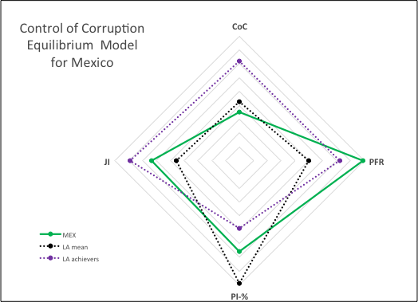

Mexico is above the high achievers in respect to party finance regulation but this is not translated in lower levels of corruption. Mexico is below the region mean in public investment as percentage of the GDP but above the high achievers, which is consistent with the findings that this kind of investment is an opportunity for corruption, specifically with lower levels of judicial independence. In this respect, Mexico is above the region’s average but below the high achievers. With this in mind, actions should be aimed at strengthening judicial independence and the rule of law.

The most important changes concerning judicial independence in Mexico could be traced to the 1990s. Foreseeing that his party was going to become the opposition for the first time in its existence, former President Ernesto Zedillo pushed for a reform in 1994 aimed at the independence of the Supreme Court. Aspects of that reform were to remove the direct designation of Judges by the Presidency and an institutional design to ensure its permanence and stability. With the PRI back in power, President Peña Nieto has been able to nominate three spots to the eleven-judge body. All of these nominations have been criticized by civil society organizations for responding to partisan quotas and the lack of transparency of the confirmation process on the Senate. (mexico evalua)

President Peña Nieto’s nomination of former Attorney General Eduardo Medina Mora was the most criticized of all three. This was due to Medina Mora’s previous role as Mexico’s top prosecutor, as well as his work in front of the defunct Secretariat of Public Safety and the organized crime division of the Office of the Attorney General. Civil society organizations denounced that Medina Mora sought to exercise discretionary power in these agencies and used them with political aims. (mexico evalua)

Furthermore, judicial independence in Mexico is limited by way the judicial branch receives its funds. The executive and legislative branches control the judiciary’s budget, so each year it has to bargain for it. Distinct from other countries, the Mexican Constitution does not specify a percentage of GDP for the judiciary. (texto de de jure independence) This makes the judiciary dependent of the political system despite all the written rules to make it autonomous.

Another challenge for Mexico’s control of corruption is related with the judiciary’s capabilities to resist organized crime. Mexico's judicial system is also highly susceptible to corruption because of what the CFR has called “autocratic judges and lack of transparency”. (CFR backgrounder) There is also lack of confidence in the justice sector, so crimes are underreported, which creates widespread impunity. (C Special Report)

A case that illustrates the weakness of the Mexican judiciary and its vulnerability in resisting private interests is the case of Judge Anuar González. The judge from the state of Veracruz ordered the release of a wealthy young man accused of sexually assaulting a schoolgirl, on the grounds that the perpetrator did not enjoy it. After the indignation over the case reached international media and lead to local protests, the Council of the Federal Judiciary suspended González and informed that it would review all of his decisions to look for any ‘irregularities’.

The recent reform to the judicial sector was seen as way to strengthen the judiciary but recent information about its implementation paint a bleak picture. Citing a study about the impact of the reform on the state of Morelos, Jose Pardinas, director of IMCO, said that one the problem is in the prosecution stage, before even a case goes before a judge. He criticized the lack of investments in training the personnel in charge of procurement, which is often overworked and underpaid. (Milenio TV)

To overcome the implementation gap of the judicial system, the IMCO focuses on improving the operating conditions of the prosecuting system. Specifically, it proposes increase the number of public defendants and experts, as well as distributing them based on criminal incidence, while guaranteeing conditions of autonomy. It also recommended increase the number of prosecuting agents and to create an Audit and Monitoring Unit to monitor the quality and delivery of justice. (Documento IMCO)

This shows that despite reform efforts, Mexico still has a long way to go in terms of ensuring the independence of its judiciary and the functioning of its judicial branch. Among the options that the government should follow are: a) ensure the transparency of the nomination process of all judges, b) guarantee the participation of civil society in this process and follow their recommendations, c) evaluate the funding process of the judiciary branch and consider locking a budget based on a percentage of the GDP or the revenue of the government to ensure its financial independence, d) improve the funding for the prosecuting part of the judicial system, so that judges can work with more efficient information e) reduce capital expenditures, public funding for political parties and invest part the savings in the of the judicial branch.

Fundamental for all of these changes is civil society. Civil society organizations have been participating increasingly in the transformations of the judicial branch, either by participating in the public debate about nominations to the Supreme Court or by assessing the success of the judicial reform.

The government should also look at the success of the high achievers in the region in terms of control of corruption and judicial independence, which are Chile, Costa Rica and Uruguay, to work towards the professionalization of the judiciary and towards a merit based system. Most importantly, the government should divest resources from capital expenditures, which are much higher than the high achievers of the region, towards the professionalization and increase of salaries of prosecuting and judiciary personnel, as well in the creation of effective oversight entities, in aims of reducing the likelihood of corruption. In the same sense, it should consider decreasing the amounts of funding of parties, since these resources are used as opportunities to corrupt and not to increase the voice of citizens on the democratic process. However, any cut to the parties’ resources could be met with resistance.

The last political reform in Mexico lead to the election of Pedro Kumamoto, an independent representative on Jalisco’s State Congress, who won his seat in 2015 when he was 25 years old. In consonance to citizens’ demands, Kumamoto has been leading a campaign to decrease funding of political parties. The proposal, which has been backed by civil society and business organizations, would calculate the funding for each party depending on turnout and not on the registered voters. Voting for the proposal has been delayed to the end of April and will be a test to see if political parties are willing to give away their resources and listen to citizens’ demands.

# References

Bértoa, Fernando Casal, Fransje Molenaar, Daniela R. Piccio, and Ekaterina R. Rashkova. 2014. “The World Upside down: Delegitimising Political Finance Regulation.” *International Political Science Review* 35(3): 355–75.

Blechinger, Verena. 2002. “Corruption and Political Parties.” *Sectoral Perspectives on Corruption* November.

Delavallade, Clara. 2006. “Corruption and Distribution of Public Spending in Developing Countries.” *Journal of Economics & Finance* 30(2): 222–39.

Fox, Jonathan. 1994. “The Difficult Transition from Clientelism to Citizenship: Lessons from Mexico.” World Politics 46(2): 151–84.

Heidenheimer, Arnold J. 1963. “Comparative Party Finance: Notes on Practices and Toward a Theory.” *The Journal of Politics* 25(4): 790.

Hopkin, Jonathan. 2004. “The Problem with Party Finance: Theoretical Perspectives on the Funding of Party Politics.” Party Politics 10(6): 627–51.

International Institute for Democracy and Electoral Assistance (IDEA). 2014. *Funding of Political Parties and Election Campaigns. A Handbook on Political Finance*. Sweden.

Karvonen, Lauri. 2007. “Legislation On Political Parties: A Global Comparison.” Party Politics 13(4): 437–55.

Mauro, Paolo. 1998. “Corruption and the Composition of Government Expenditure.” *Journal of Public Economics* 69: 263–79.

Mauro, Paolo. 1998. “Corruption: Causes, Consequences, and Agenda for Further Research.” *Finance and Development* 35(1): 11–14.

Mungiu-Pippidi, A. 2015. *The quest for good governance: how societies develop control of corruption*. Cambridge University Press.

Pierre, Jon, Lars Svåsand, and Anders Widfeldt. 2000. “State Subsidies to Political Parties: Confronting Rhetoric with Reality.” West European Politics 23(3): 1–24.

Pinto-Duschinsky, Michael. 2002. “Financing Politics: A Global View.” Journal of Democracy 13(4): 69–86.

Posada-Carbó, Eduardo. 2008. Kellogg Institute Working Papers Democracy, Parties and Political Finance in Latin America.

Scarrow, Susan E. 2004. “Explaining Political Finance Reforms Competition and Context.” *Party Politics* 10(6): 653–75.

Scarrow, Susan E. 2007. “Political Finance in Comparative Perspective.” *Annual Review of Political Science* 10(1): 193–210.

Tanzi, V., and H. Davoodi. 1997. “Corruption, Public Investment and Growth.” *IMF Working Papper*: 41.

Van Biezen, Ingrid. 2004. “Political Parties as Public Utilities.” Party Politics 10(6): 701–22.

Van Biezen, Ingrid, and Peter Kopecky. 2007. “The State and the Parties: Public Funding, Public Regulation and Rent-Seeking in Contemporary Democracies.” Party Politics 13(2): 235–54.

Wilcox, Clyde. 2001. *Transparency and Disclosure in Political Finance: Lessons from the United States Clyde*.

1. We understand Latin America according to the selection of eighteen countries done for this thesis.
2. https://www.argentinacompra.gov.ar/prod/onc/p8081/estadisticas/compras.jsp